Creating a CalJOBS WIOA Application

The following screen shots reflect the required steps to create a customer Application. Search for the customer for which you want to create the WIOA Application.

NOTE: Prior to creating a WIOA application, staff should verify whether or not the customer has an existing WIOA Application in CalJOBS before creating a new WIOA application. In addition, staff should also verify that all eligibility documents (e.g. CalJOBS Registration-Addendum, RTW (Right-to-Work), Veteran documents, etc.) have been scanned into the customer’s Documents folder.

In addition, staff should verify that the customer has a fully completed Registration in CalJOBS prior to the creation of the WIOA Application as many of the fields in the Application are pre-populated from the Registration.

Choose Manage Individual and then Assist an Individual

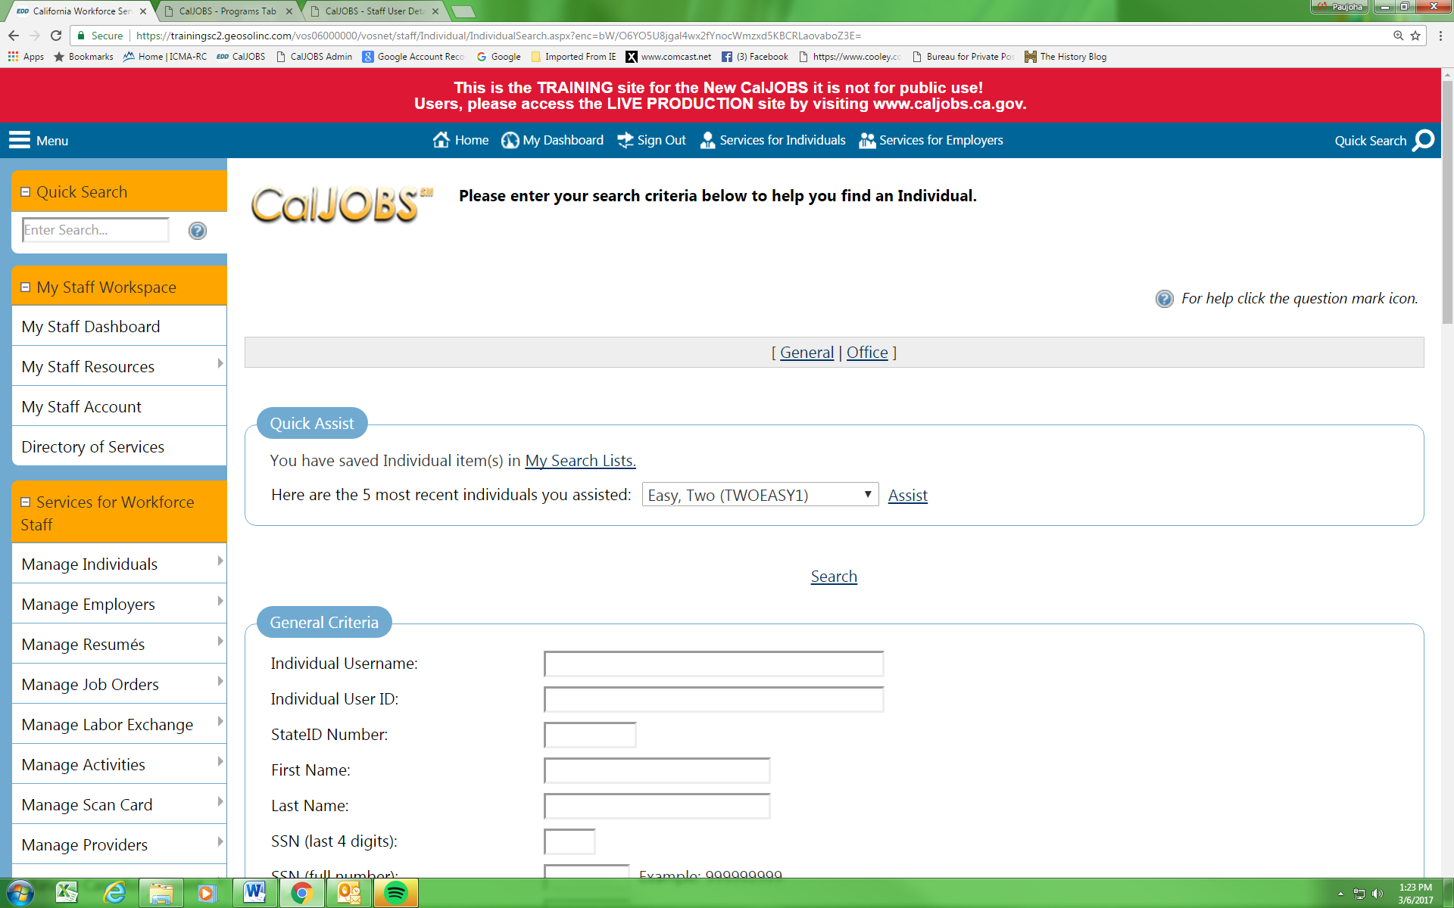

In the General Criteria section, enter customer information (e.g customer’s last name with last 4 of the SSN, the complete SSN, etc.) and click Search. If you are unable to locate the customer, the customer may not be registered in CalJOBS (or the search criteria being used are incorrect).

NOTE: If customer is not registered, have the customer create a CalJOBS registration. Occasionally it may become necessary for staff to create the customer’s registration for them (using a current, completed CalJOBS Registration Form). If this becomes necessary, staff MUST create the Registration using the customer’s information and not be logged into CalJOBS a staff person.

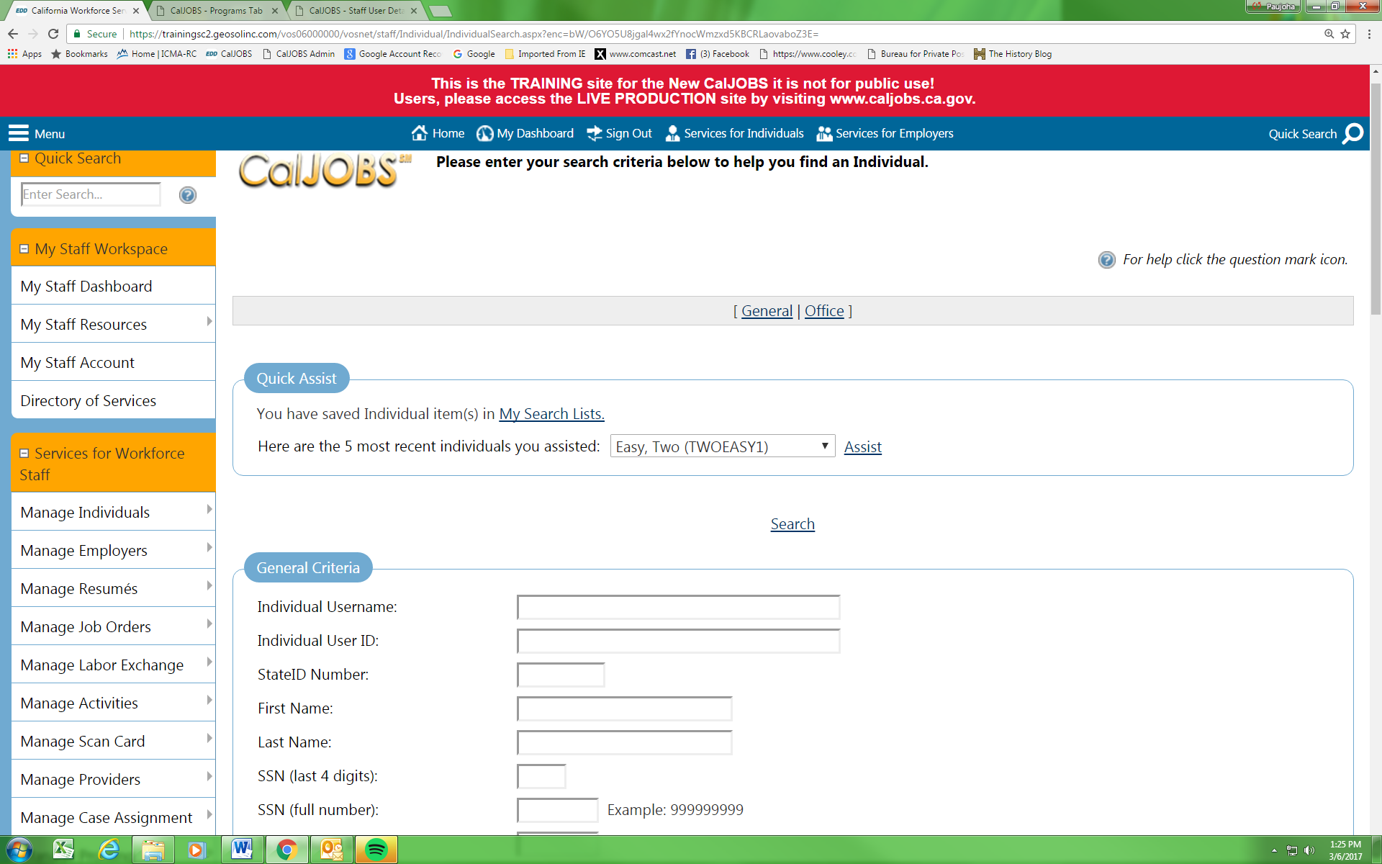

If the customer is already registered in CalJOBS, a summary list of customers matching the specific search criteria will appear. Select the Programs link under the Action column for the appropriate customer.

NOTE: Staff MUST bypass the Right to Work Verification screen by scrolling to the bottom of the screen and selecting “Remind me later”.

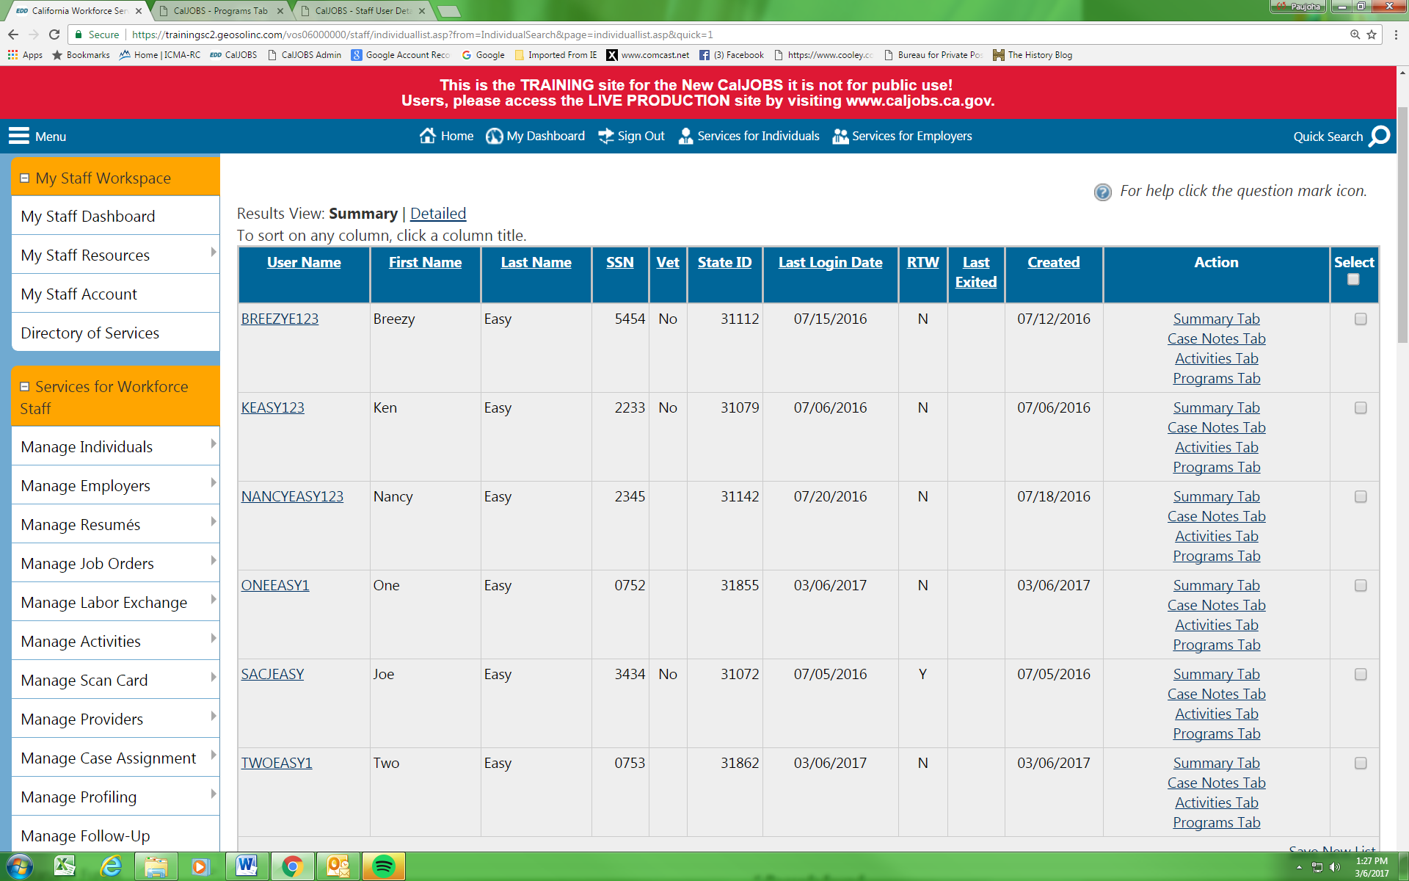
Scroll down to the Workforce Innovation and Opportunity Act (WIOA) Program section.

Then select Create Workforce Innovation and Opportunity Act (WIOA) Program.

NOTE: If the Workforce Innovation and Opportunity Act (WIOA) Program does not reflect “Apps: 0” be sure to check to see if the previous WIOA Application is still “Open”. If the indicator at the end of the application indicates “Closed” a new WIOA application can be created. If the indicator reflects “Complete” then a new WIOA application CANNOT be created at this time.

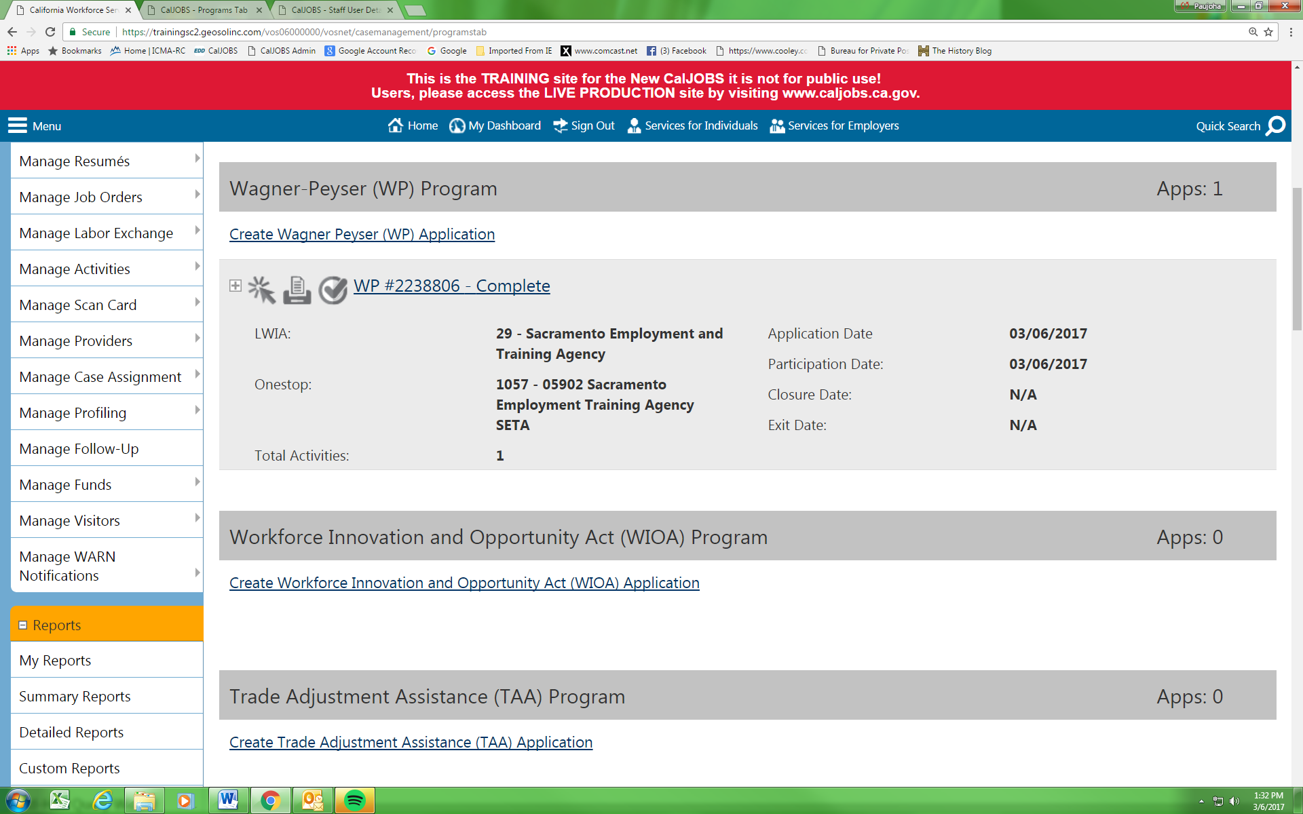

In the Application/Registration Information section staff must enter the Application date. Staff will then select the customer’s eligibility (Adult or Dislocated Worker) and enter the date of eligibility.

NOTE: Be sure to consider whether or not to back date the Application Date. Staff are not able to backdate the application date more than 30 days from the date of application creation. In addition, ALL of the fields indicated by a red asterisk () must be completed.

NOTE: If the customer is a Dislocated Worker but staff want to enroll the customer into Adult activities both Adult AND Dislocated Worker Eligibility boxes must be checked)

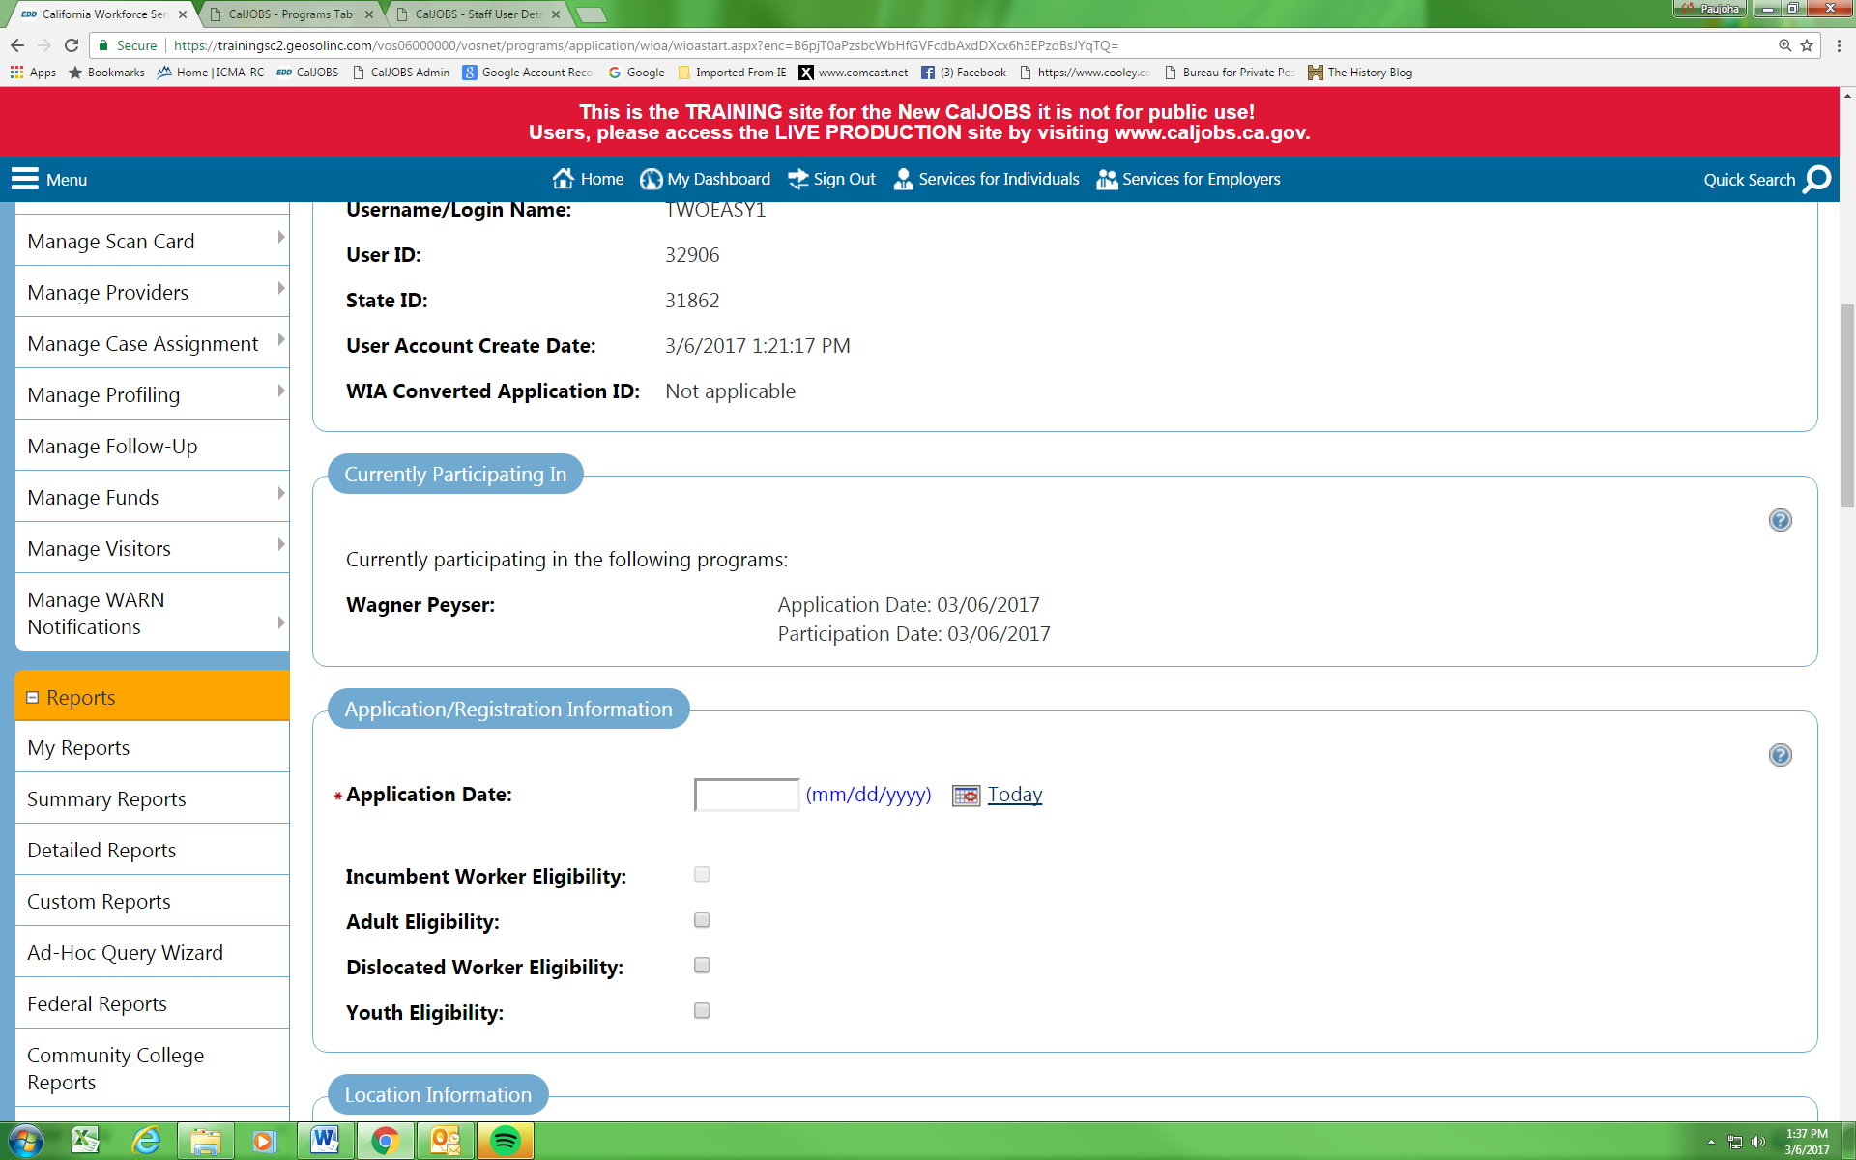
In the Location Information section, staff must select the Office Location of Responsibility as well as the Office Location (it is critical that the correct Offices be selected so that the center will get credit for the enrollment). Staff must also select the appropriate agency by clicking on the Agency Code Search link. If staff are located at an AJCC they should use this as the search criteria since several of the AJCCs are also Providers (which is a separate Agency Code)

Select Next at the bottom of the screen.

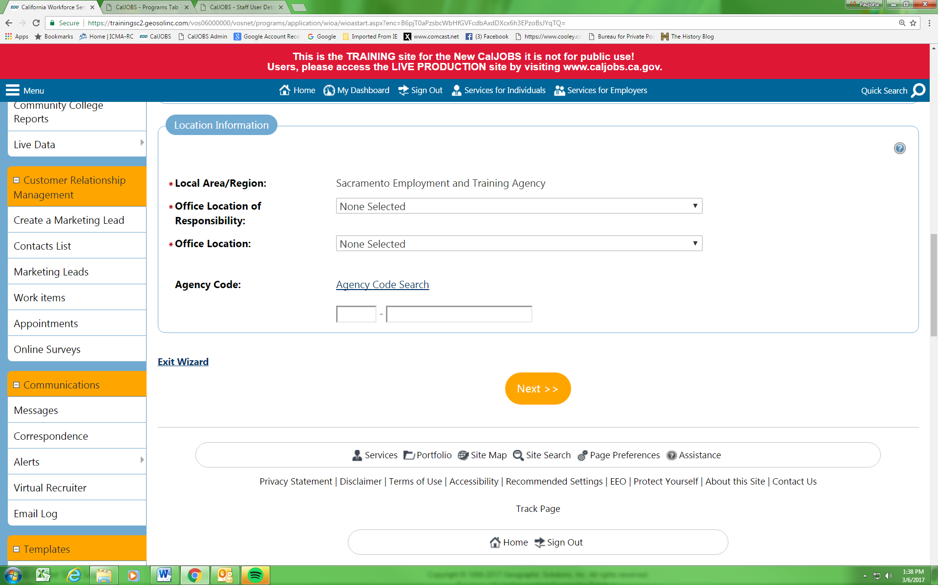

The next screen reflects the customer’s Contact Information (populated from the Registration).

NOTE: ALL of the fields indicated by a red asterisk () must be completed. If the customer’s Mailing Address is the same as their physical address, select the check box next to Check here to use residential address information to populate this section.

Select Next at the bottom of the screen.

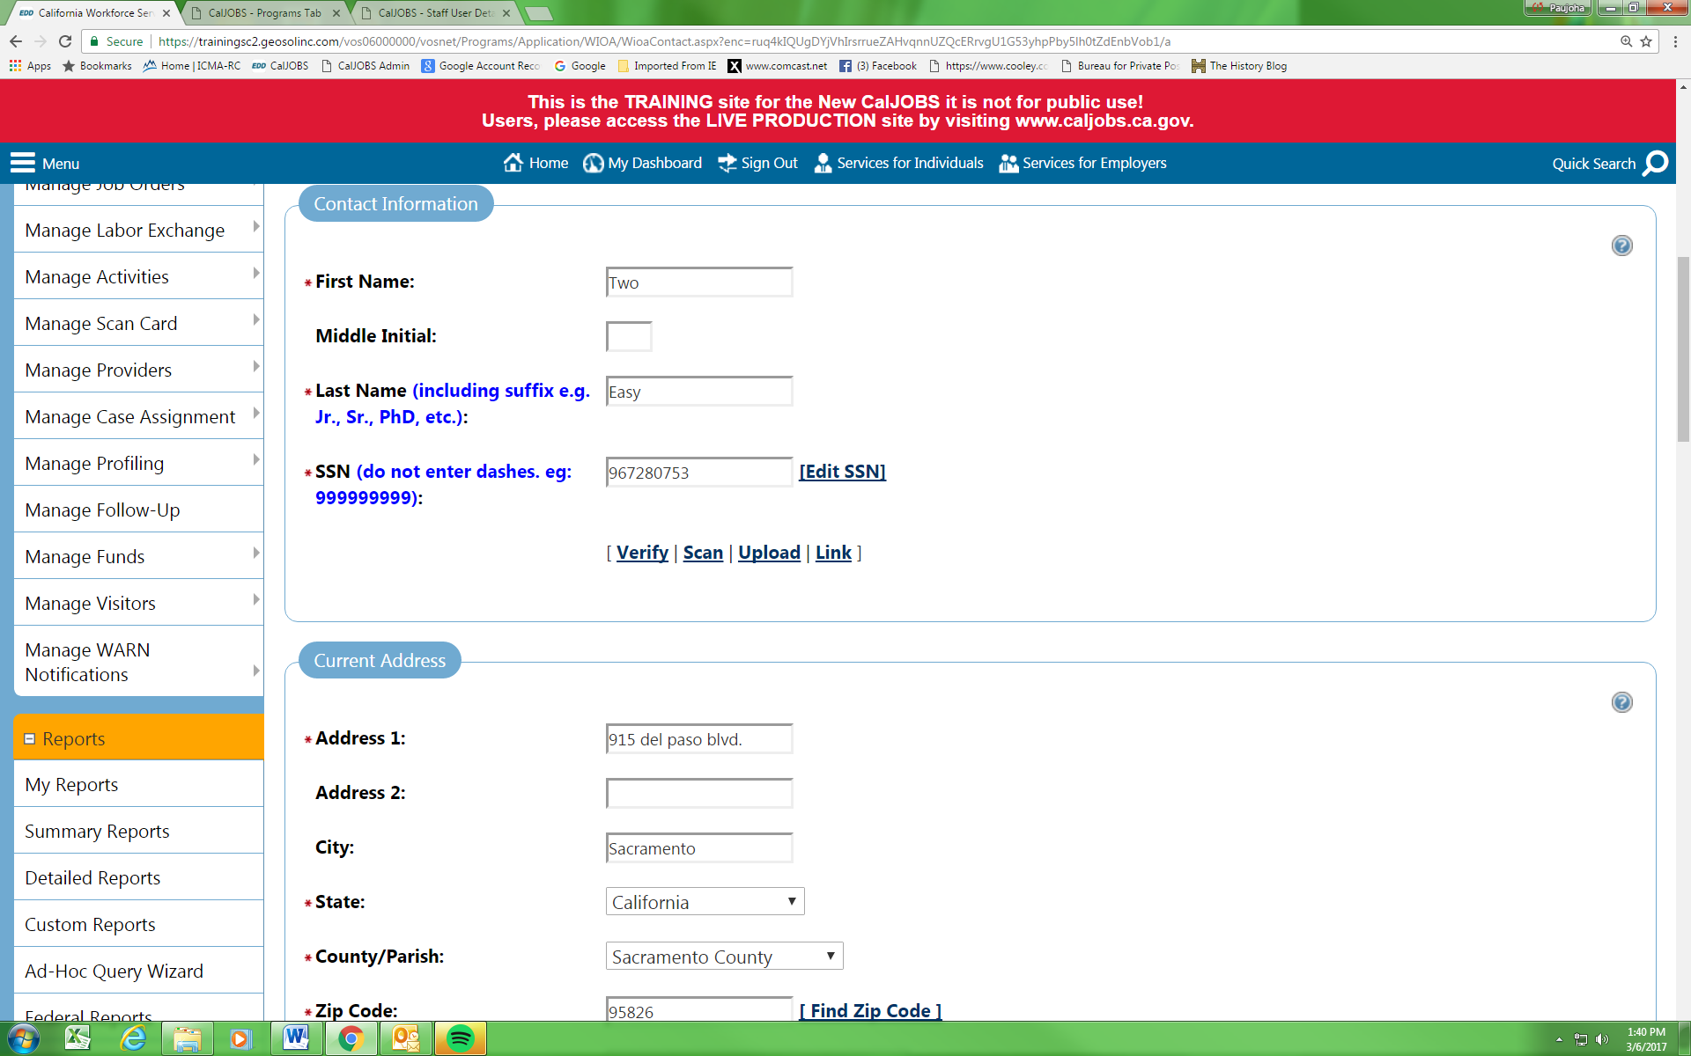
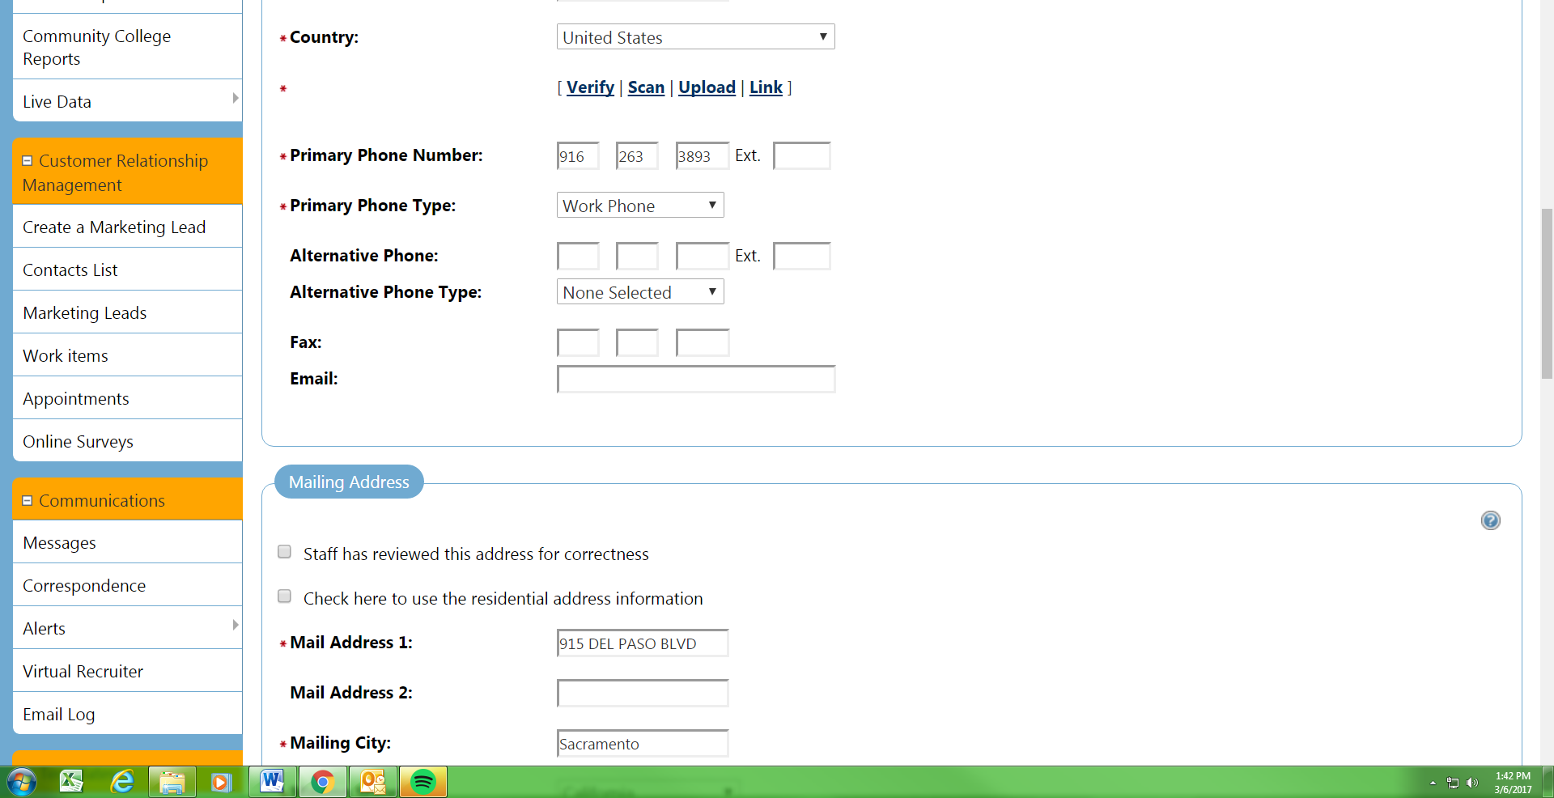
In the Demographic Information section, if the customer is a Male, 18-25 years of age, they must be registered with Selective Service. Staff must now go to the Selective Service Website (hyperlink) to verify registration. Proof of registration may be scanned into the customer’s Documents folder. The Selective Service Registration Number and Date should also be entered into the appropriate fields within the Demographic Information section.

For those customers not registered for Selective Service (and who were born on or after January 1, 1960), a Selective Service Status Letter along with an Applicant Statement explaining why they did not or are not registered with Selective Service must be completed. These 2 documents must be scanned into the Customer’s Documents folder (see “CalJOBS document scanning” screen shots). The signed copy of the Selective Service Status Letter must be mailed to Selective Service by the customer’s Coach. If submitting a status letter, the Registered with the Selective Service box should be set to Documented Exemption from Registration.

In the Disability section, please indicate whether the customer considers themselves to have a disability and, if yes, enter the type of disability in the Category of Disability section.

Select Next at the bottom of the screen.

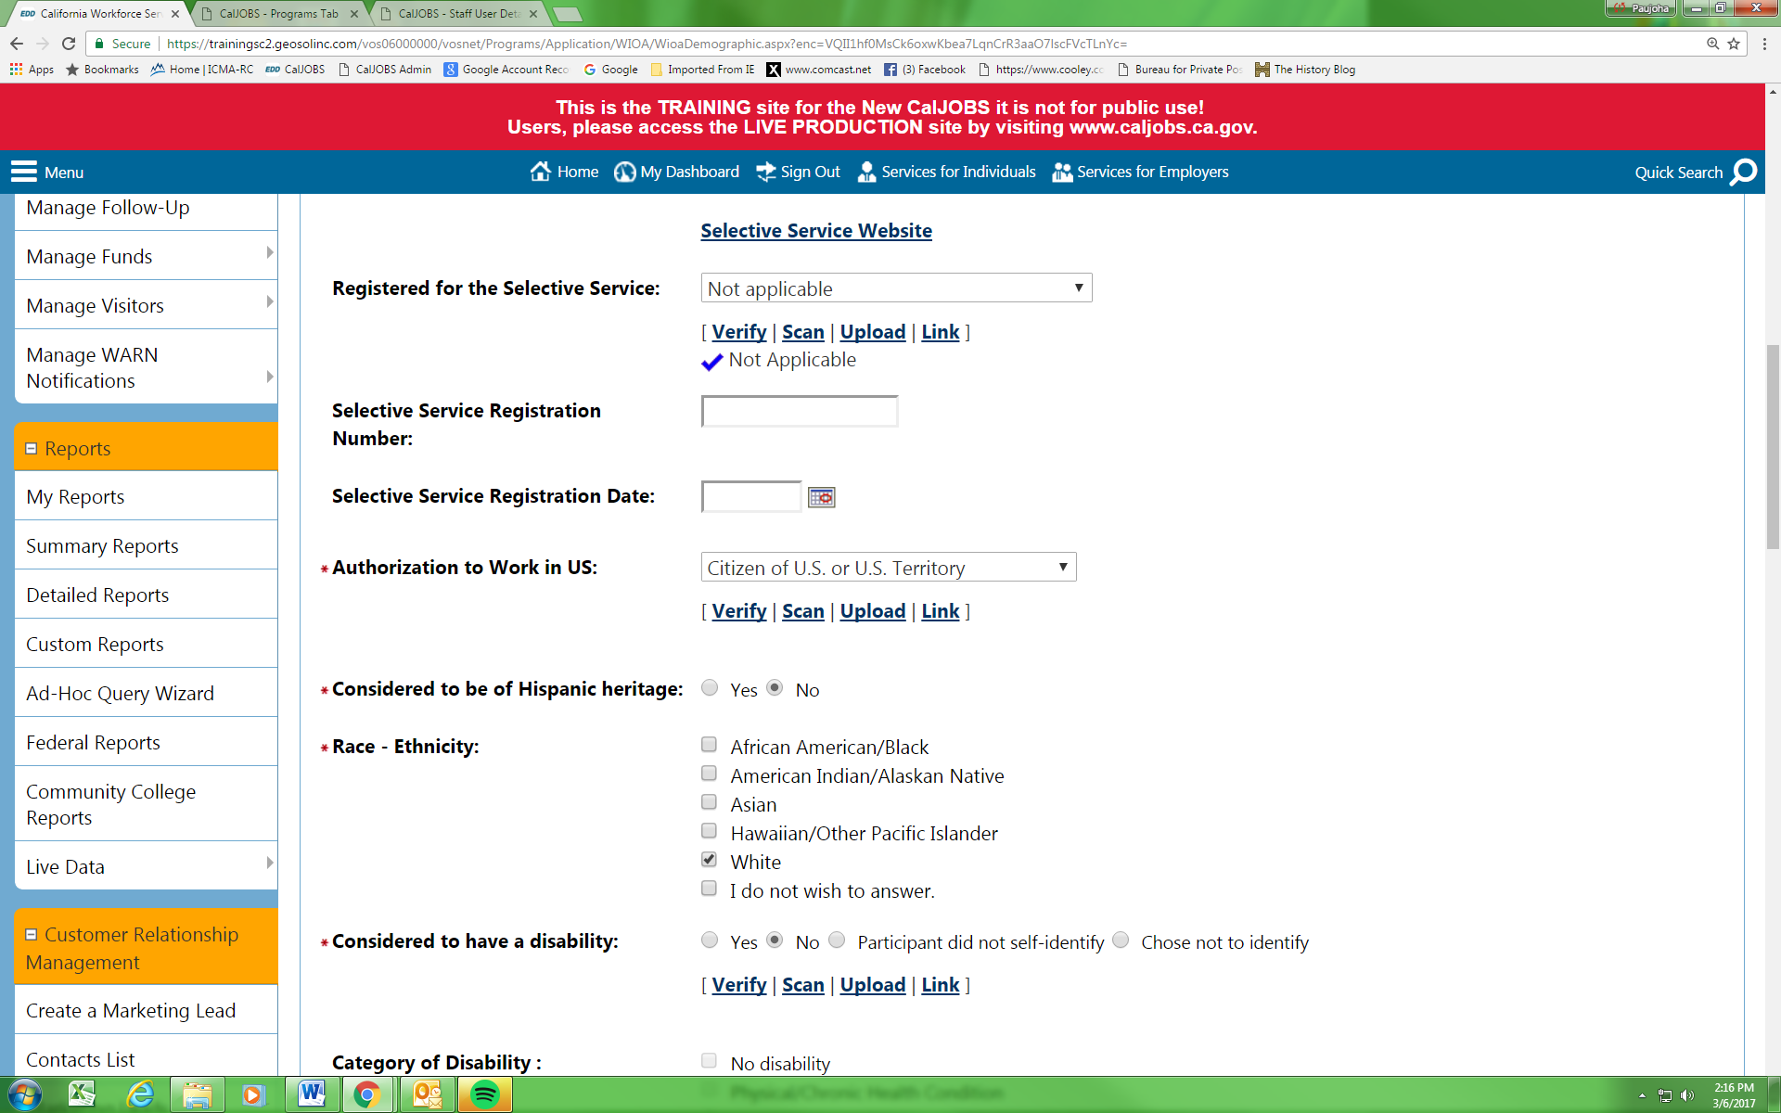
Review and enter relevant Military detail in the Transitioning Service Member and Veteran Information sections, if necessary.

Select Next at the bottom of the screen.

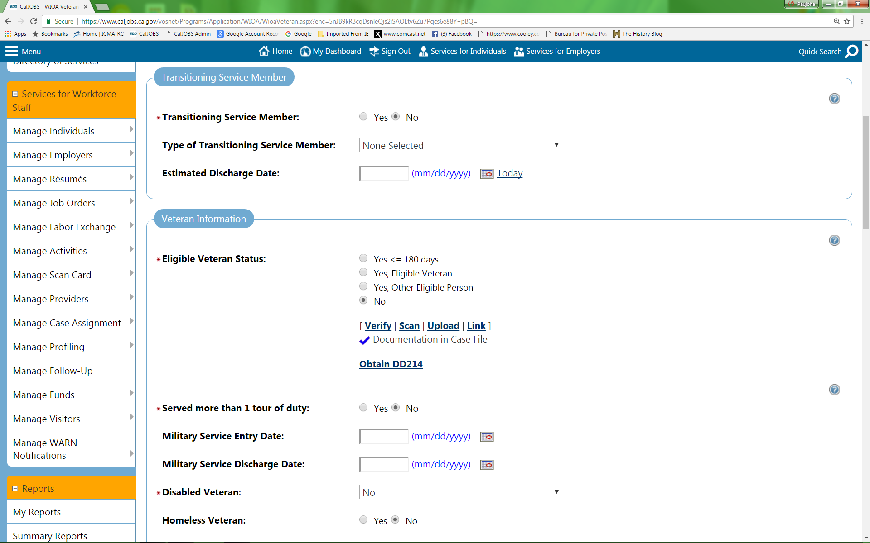
In the Employment Information section, the Number of Weeks Unemployed requires a value if the customer’s Employment Status reflects “Not Employed”.
The Number of Weeks Unemployed is no longer restricted to a maximum of 26. If the number of weeks is 27 or greater, please select a Yes response to the Long-term unemployed question.

NOTE: In addition, the customer’s Employment History can be entered in this section.

Select Next at the bottom of the screen.

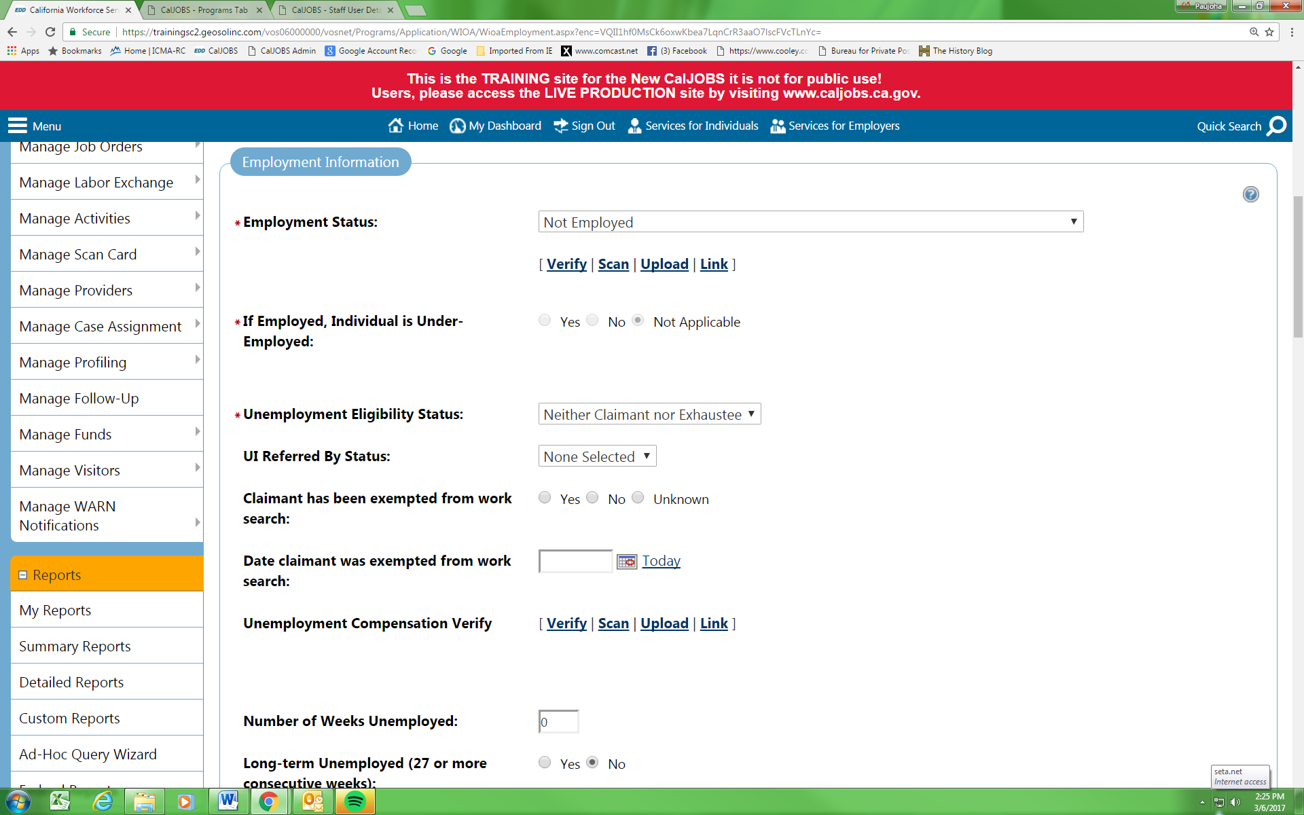
If the customer has been identified as a Dislocated Worker the appropriate Dislocated Worker Category must be selected. In addition, the Actual Date of Layoff and the employer of dislocation detail must be entered (Projected Layoff Date should be left blank unless the customer’s layoff date has not yet occurred).

If the customer has included their Employment History in their Background Information section of their Registration, you can also click on the “Search Individual Employment History” to capture the employer detail.

NOTE: If staff have selected Adult Eligibility only, this Dislocated Worker section of the WIOA Application will not appear.

Select Next at the bottom of the screen.

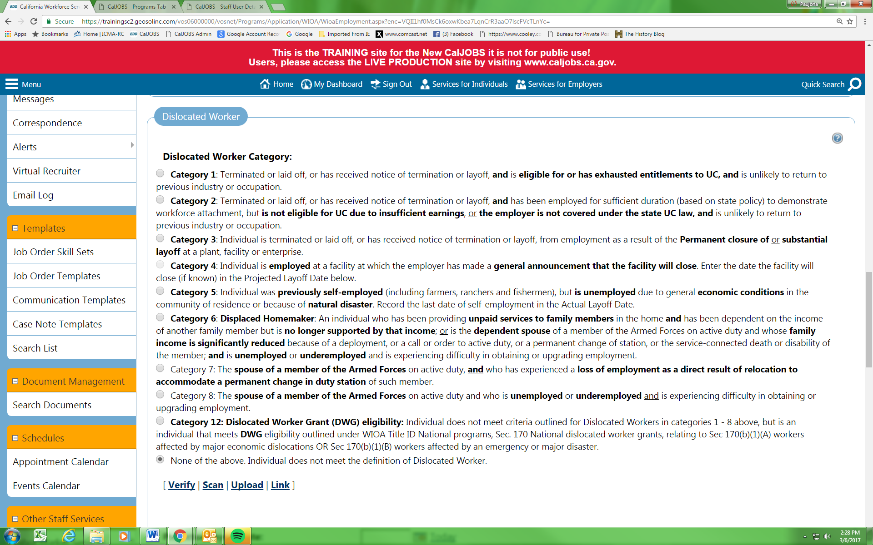
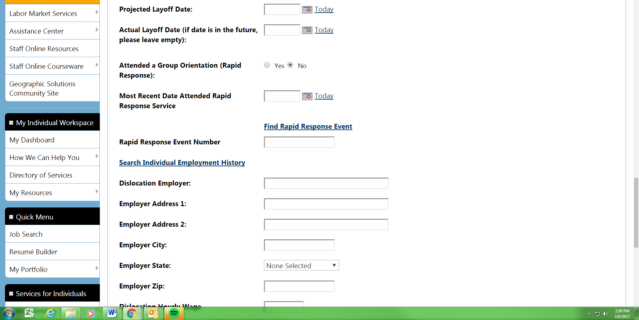

The WIOA Education Information (“Highest School Grade Completed”, “High School Diploma or Equivalent”, “Highest Education Level Completed”, and “School Status”) must be completed.

In addition, Review, and modify if necessary, relevant fields in the Education Partner Services section.

Select Next at the bottom of the screen.
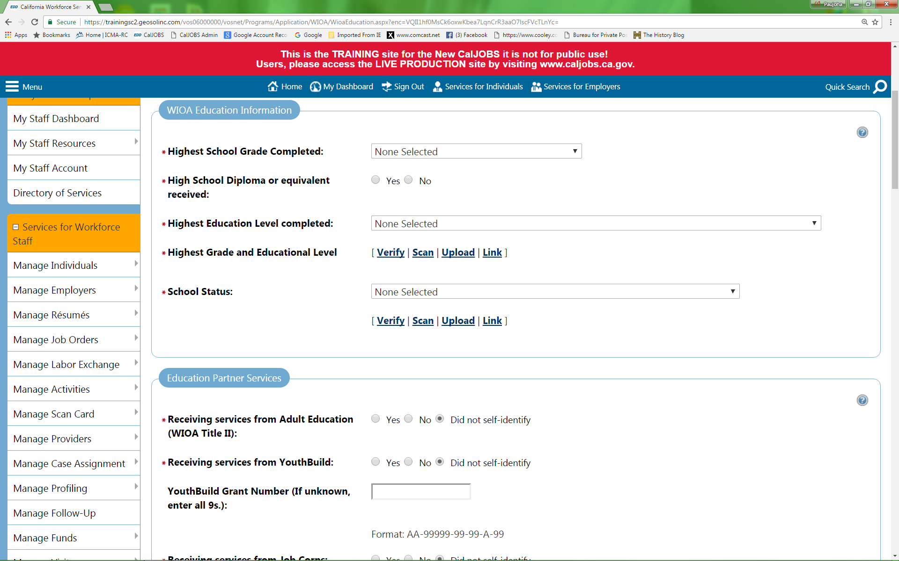
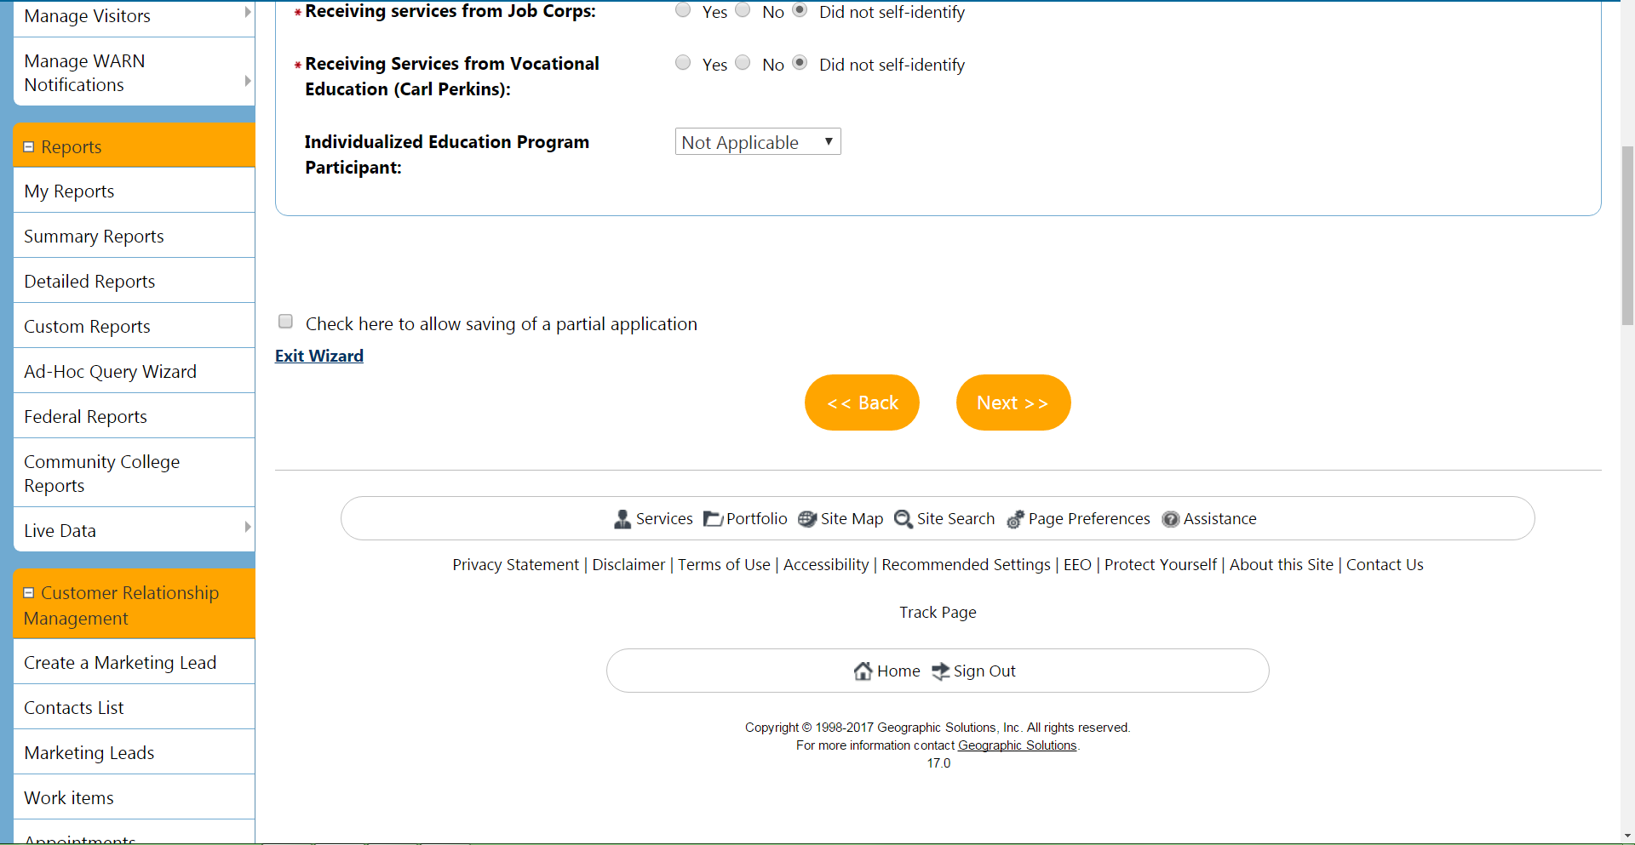
Review, and modify if necessary, relevant fields in the Public Assistance fields in the customer’s Registration - Application.

Select Next at the bottom of the screen.
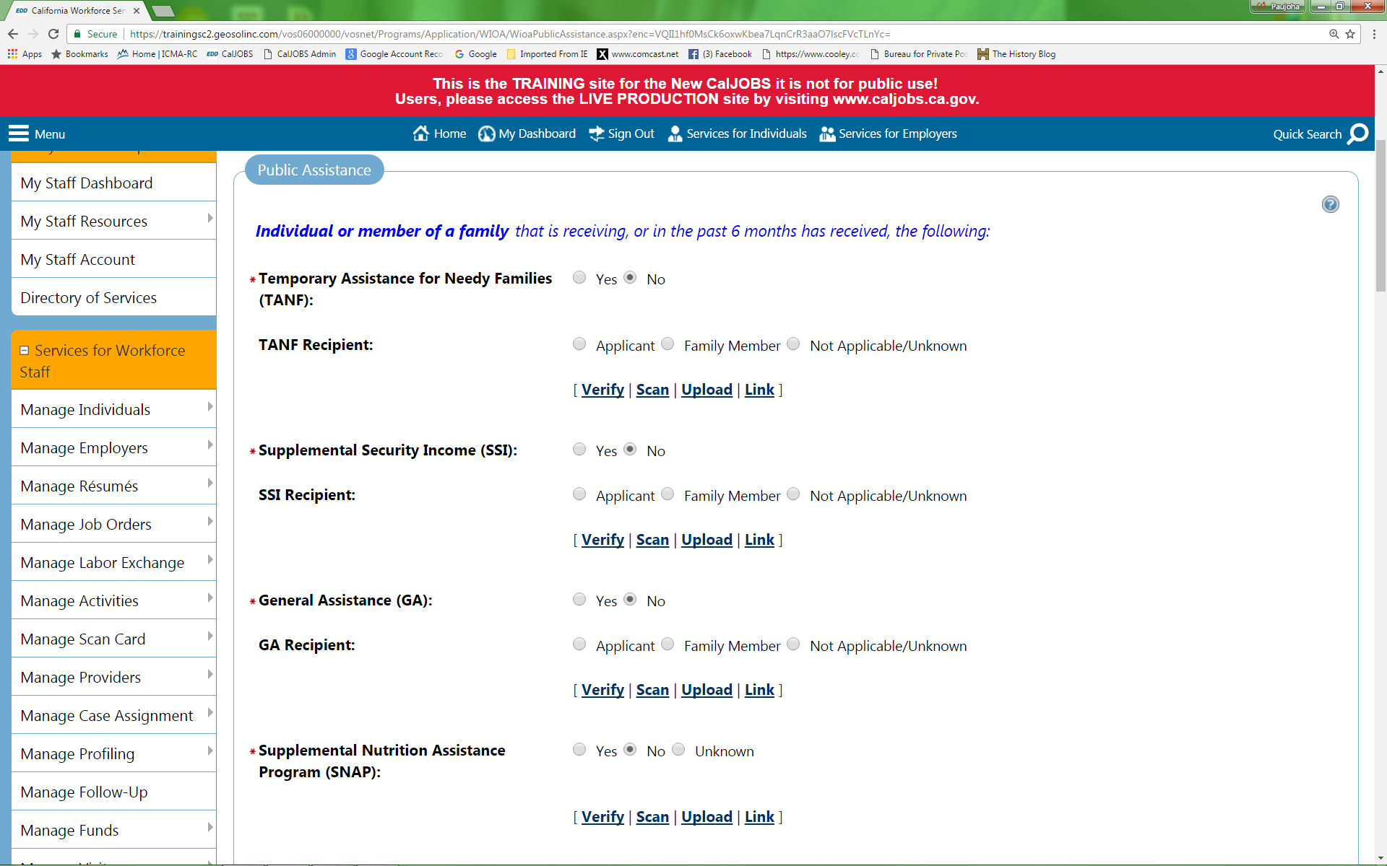
Review, and modify if necessary, relevant fields in the Individual Barriers and Barriers to Employment Information sections.

Select Next at the bottom of the screen.

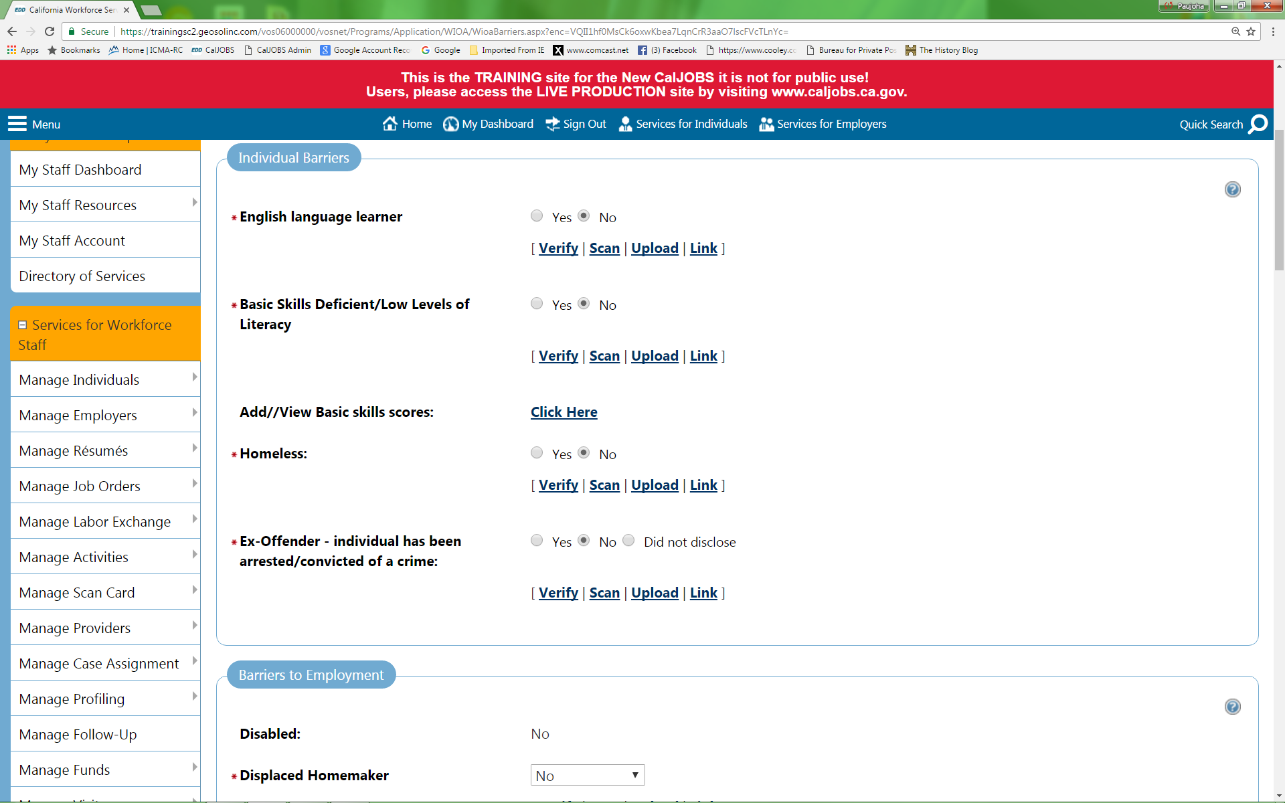
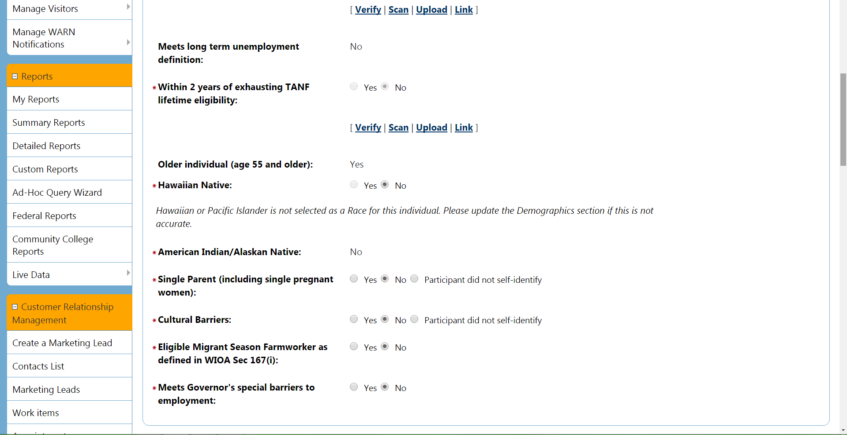
Review and modify Family Income section. The Family Size and Annualized Family Income fields are mandatory fields, the information must be included.

Select Next at the bottom of the screen.
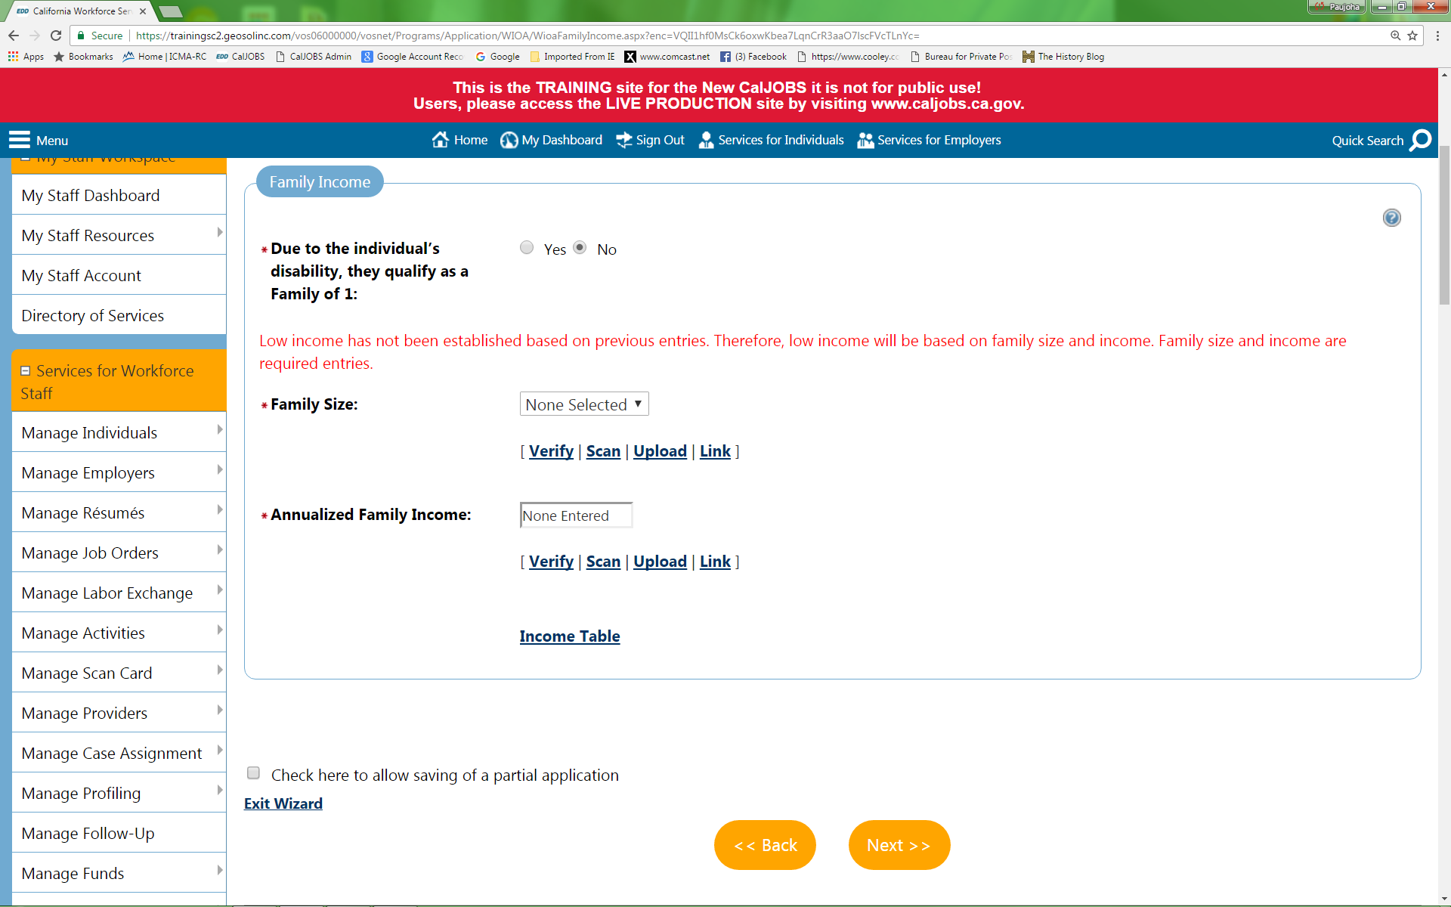

Review, and modify if necessary, relevant fields in the Barriers section.

Select Next at the bottom of the screen.

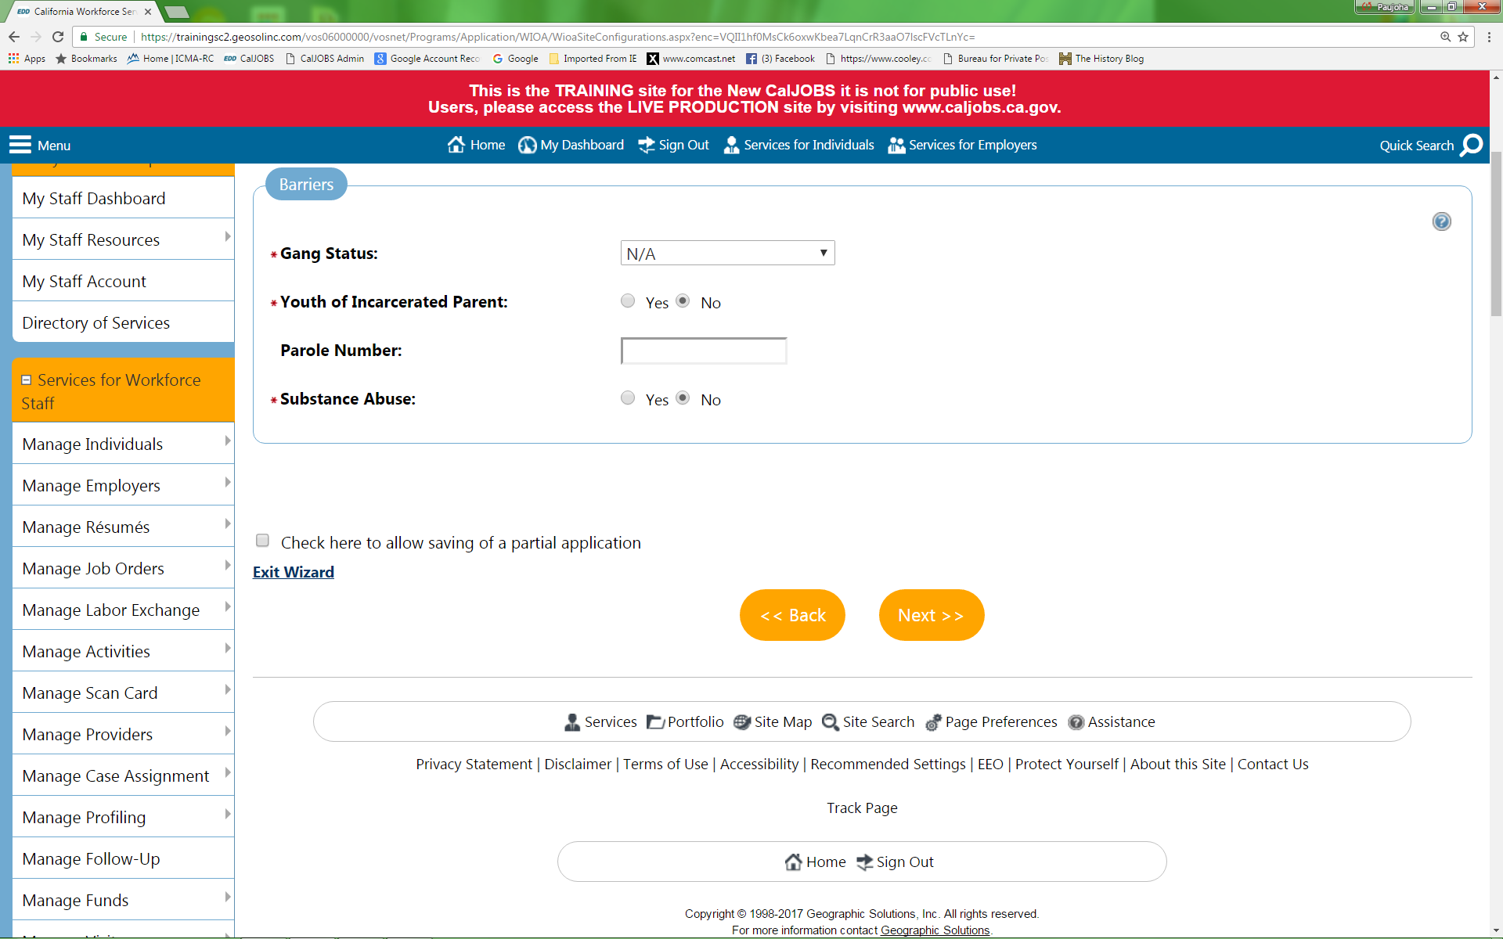
The customer’s WIOA eligibility, Adult (201), Dislocated Worker (501) and/or Youth (301), is reflected in the Application Eligibility section. If staff are intending on enrolling the customer into a Statewide, Non WIOA, or Local Grant (e.g. 901, etc) the appropriate grant selection should be made in the WIOA Grant Eligibility or Non-WIOA Grants section(s). Once the relevant grant selection has been made staff can select the “View Available Grants” link in the Grants section to select and add the appropriate grant(s) to the customer’s eligibility. Also, in the Staff Eligibility Information section the Case Manager can be assigned.

Select Finish at the bottom of the screen.

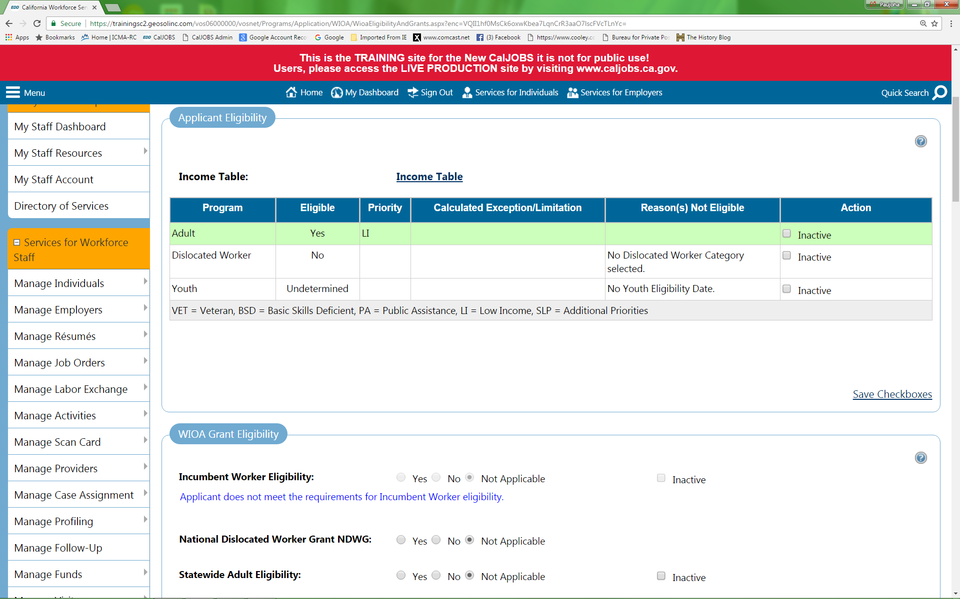
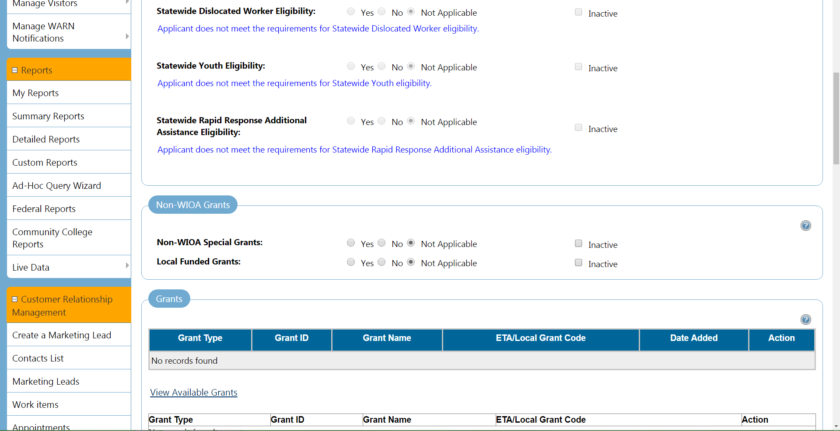
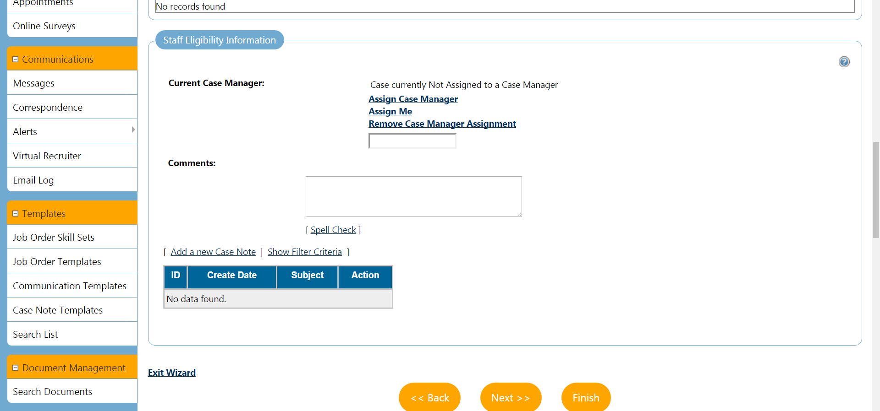
The customer’s WIOA Application is now complete. Expand the plus (+) sign next to the customer’s WIOA Application to view the various sections (Eligibility Summary, Participation, Activities/Enrollments/Services, etc.) associated with the WIOA Application.

NOTE: Modifications to an open (Complete) WIOA Application can now only be made by using the button (next to the WIOA App) and selecting the appropriate tab. Staff can also choose to use the Next option to go through the app screen by screen.



