Creating a CalJOBS Participation

Prior to beginning the actual creation of a customer Participation, staff should verify that all eligibility documents (e.g. CalJOBS Registration-Addendum, Right-to-Work, Veteran’s documents) have been scanned into the customer’s Documents folder. The following screen shots reflect the required steps to create a customer’s Participation.

On the left vertical menu, choose hover over Manage Individual and select Assist an Individual

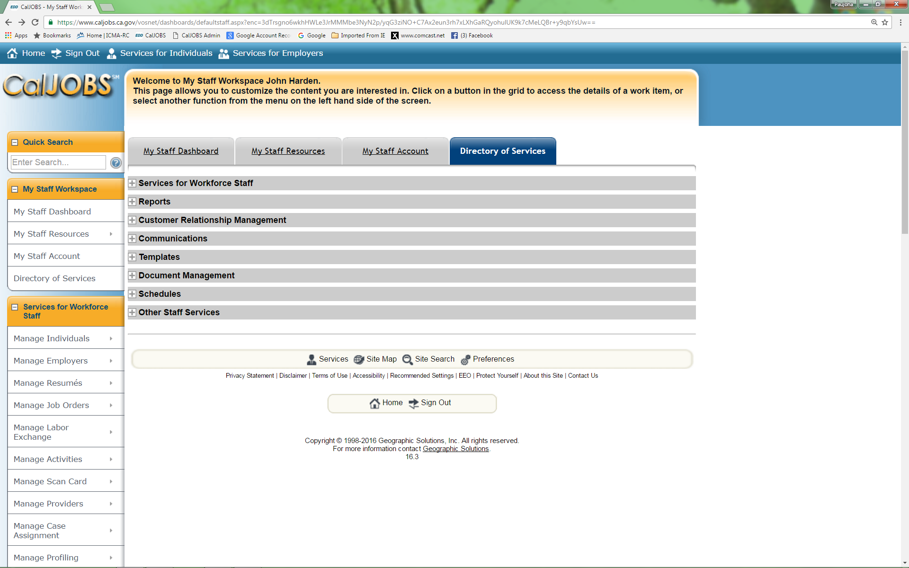

In the General Criteria section, enter minimal customer information (e.g customer’s last name with last 4 of the SSN, the complete SSN, etc.) and click Search.

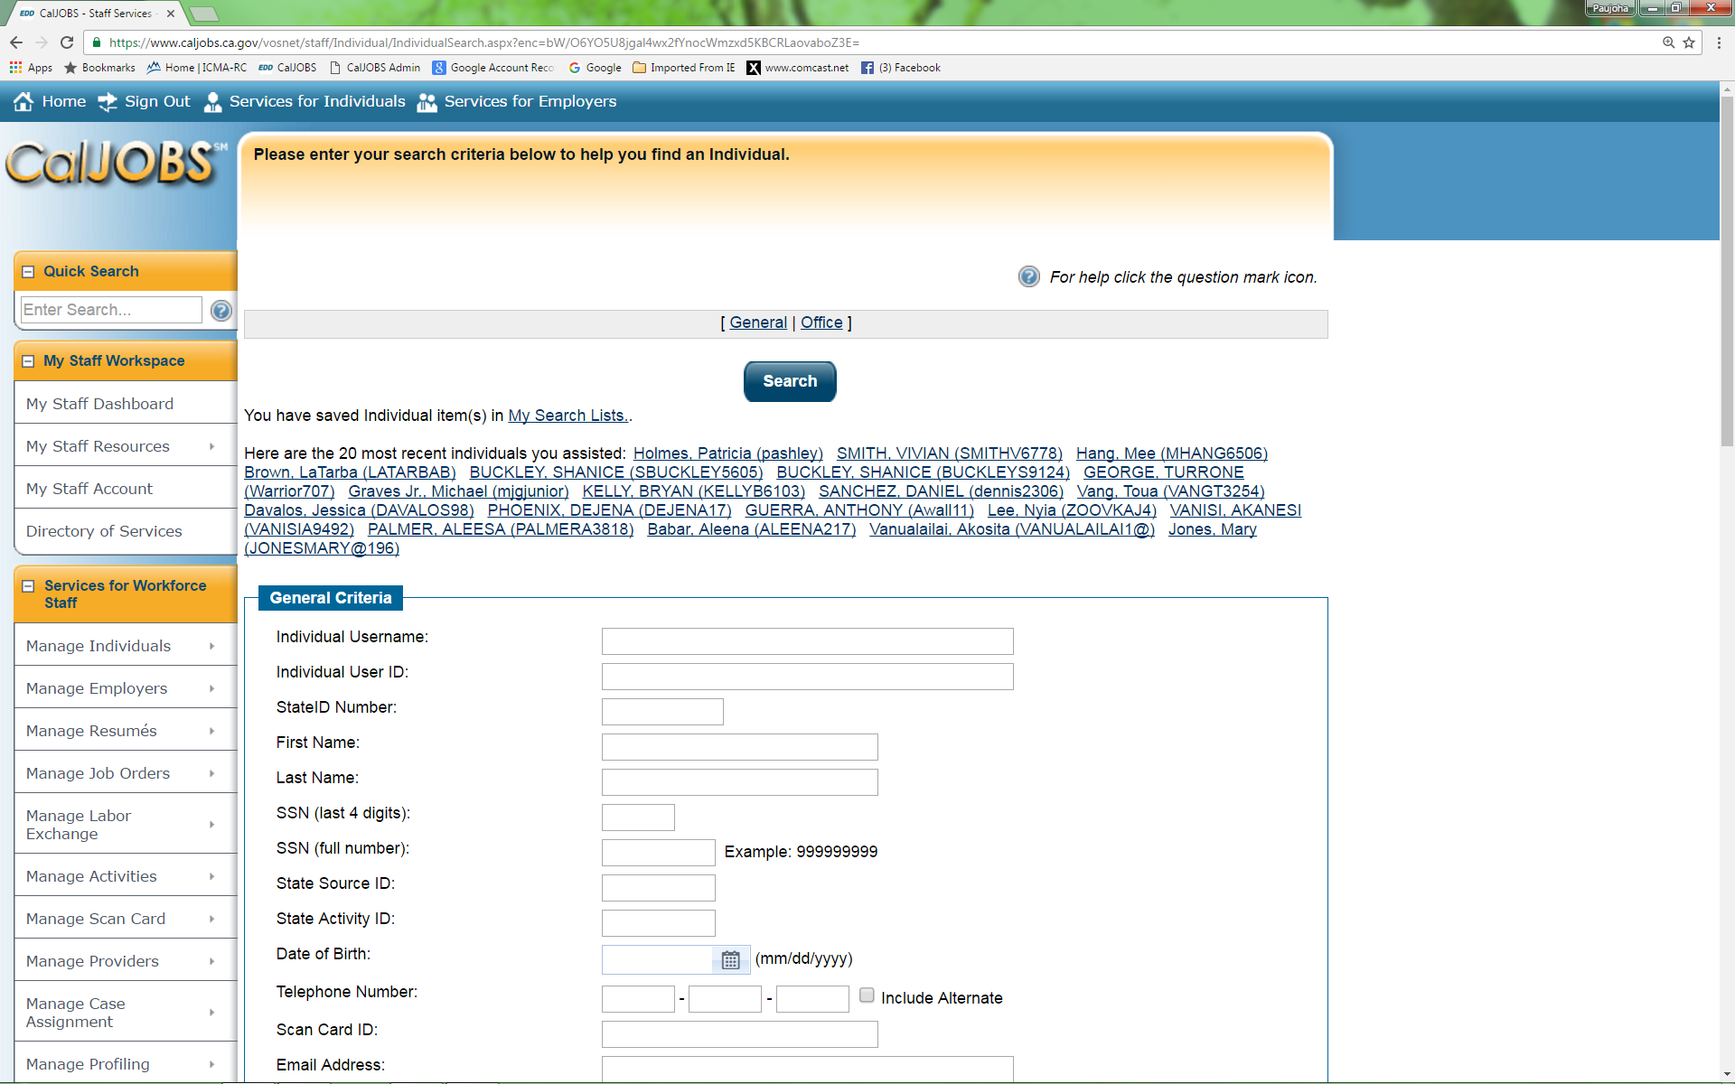

A summary list of customers meeting the search criteria will appear, choose the Programs link under the Action column for the appropriate individual

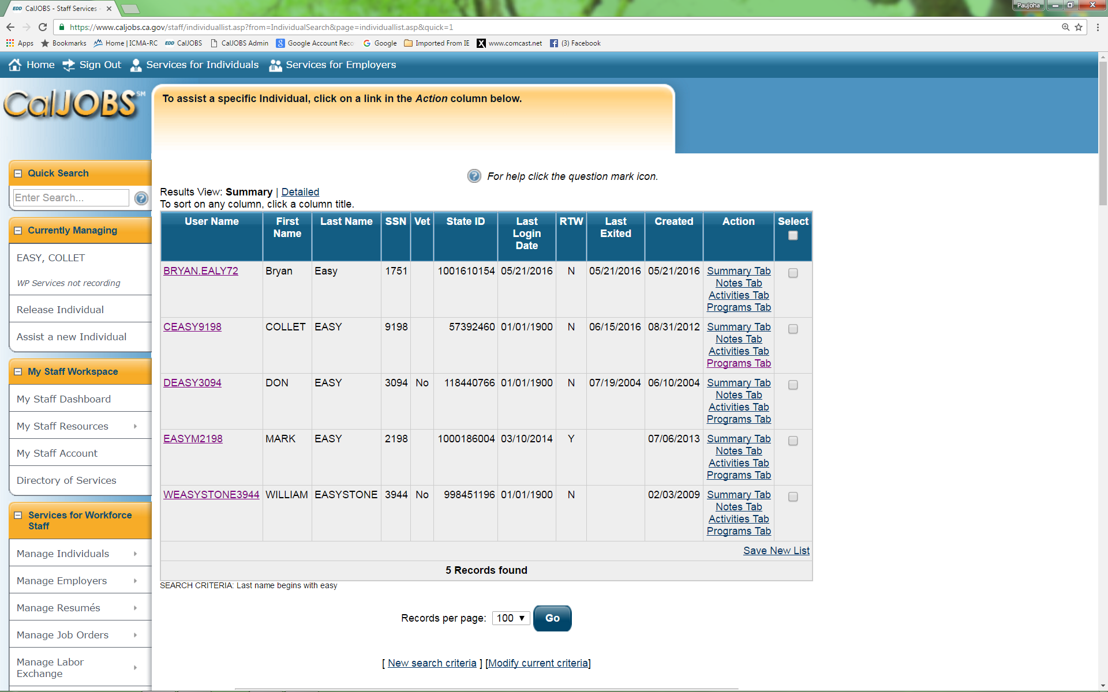
On the Programs tab click the + in front of the Workforce Investment Act (WIA)
Program.

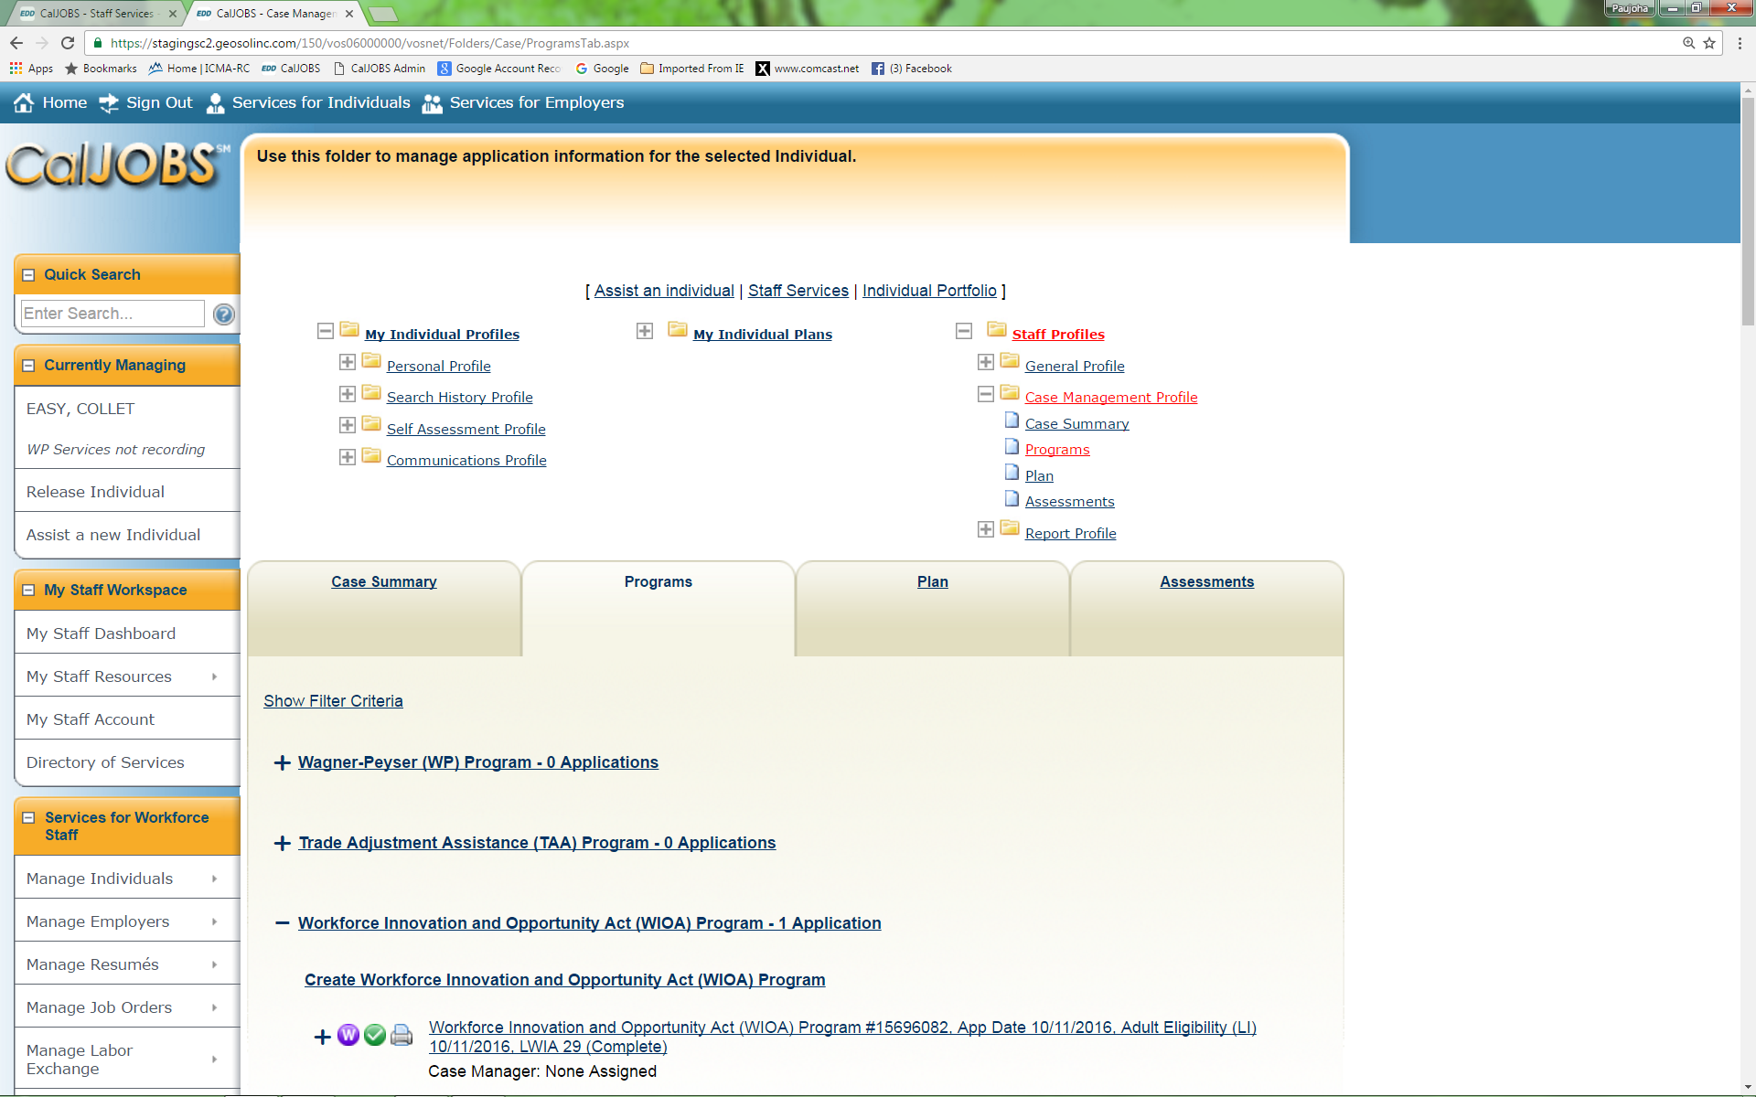

Click Create Participation

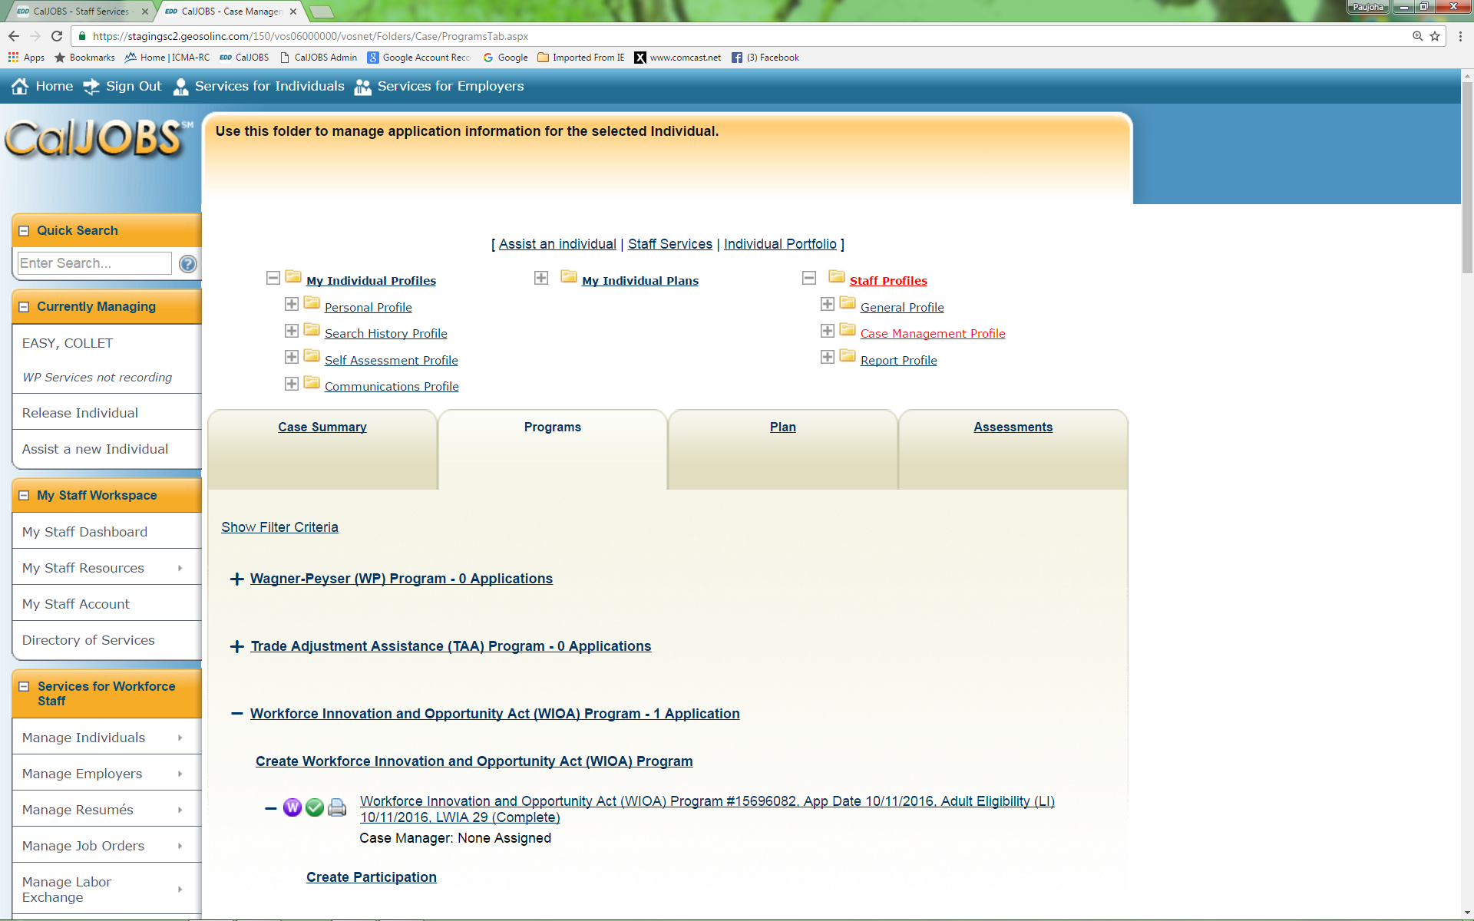

In the Participation Information section, enter the appropriate Participation date. The Participation Date cannot be back-dated more than 30 days. Once the Participation Date is entered use the Tab key to populate the Participation Age.

Select “Next” at the bottom of the screen

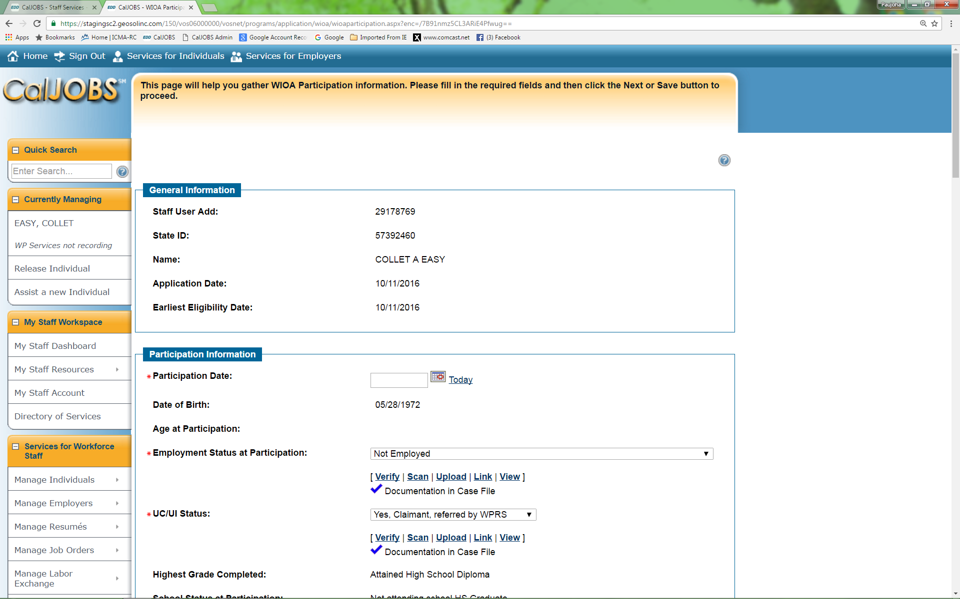
In the General Information section:
Select the appropriate Customer Program Group, Office Location, and Agency Code

NOTE: Select the appropriate Agency Code through the Agency Code Search link. When searching for the job center use AJCC to identify the correct agency (many job centers are also providers which reflects a different agency code).
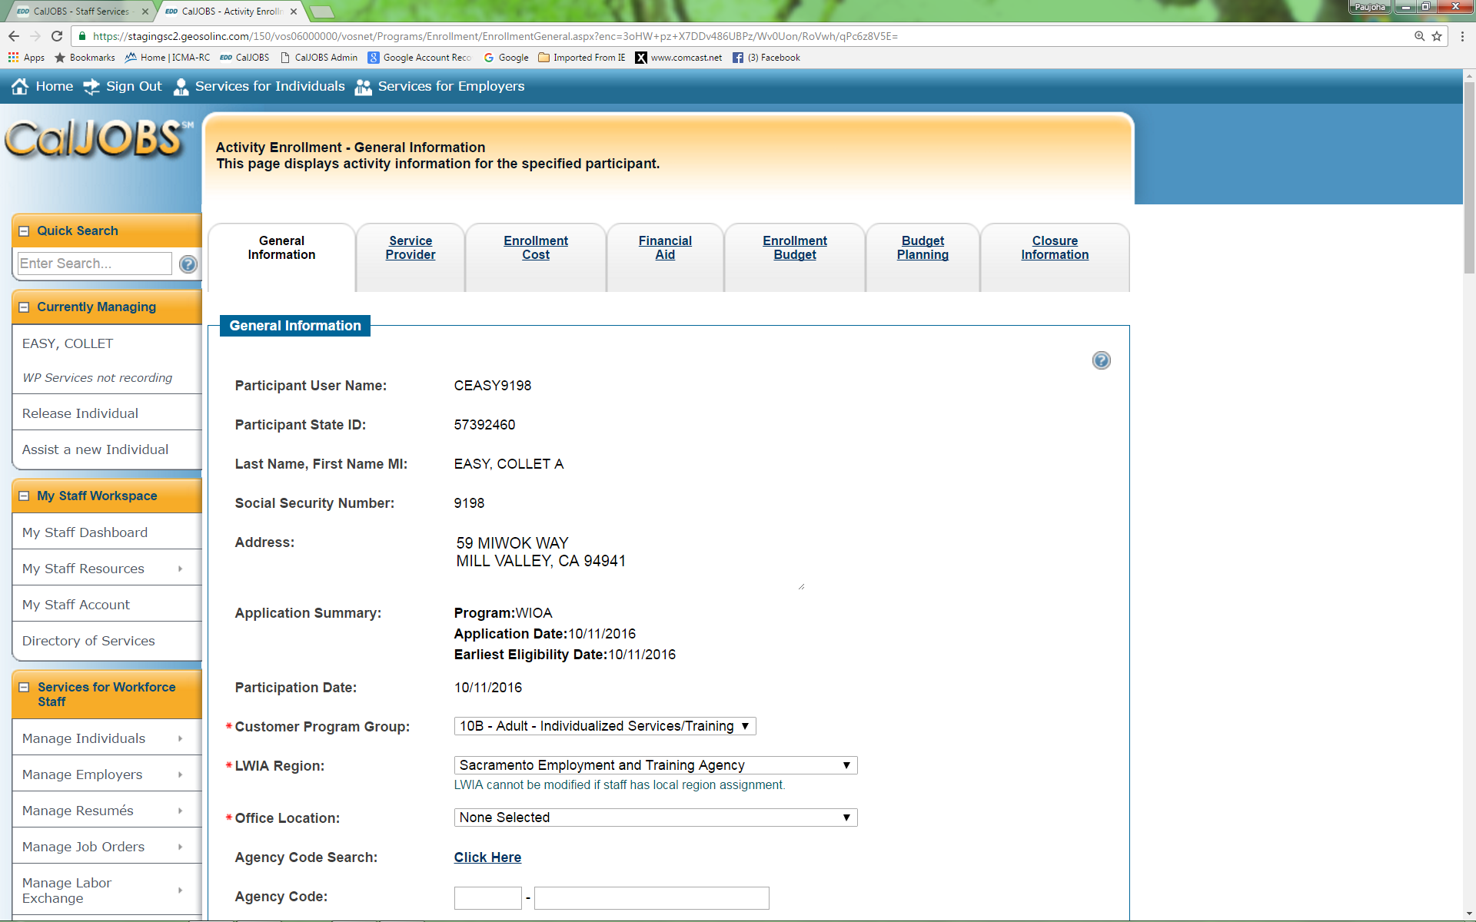

In the Enrollment Information section:
Select an Activity Code 102 (Initial Assessment) using the Select Activity Code search link (If enrolling customer into a grant other than formula (e.g. 201, 501, 301) the Grant must be selected from the grant drop-down menu).
Choose a Projected Begin Date
Choose a Projected End Date.

NOTE: The Participation is a “Same Day” Service so the Begin and End Dates should reflect the same date. The Actual Begin Date is determined when the WIA Application is created so if you need to change the Actual Begin Date it must be done in the customer’s WIA Application. Remember, these dates cannot be backdated more than 30 days.
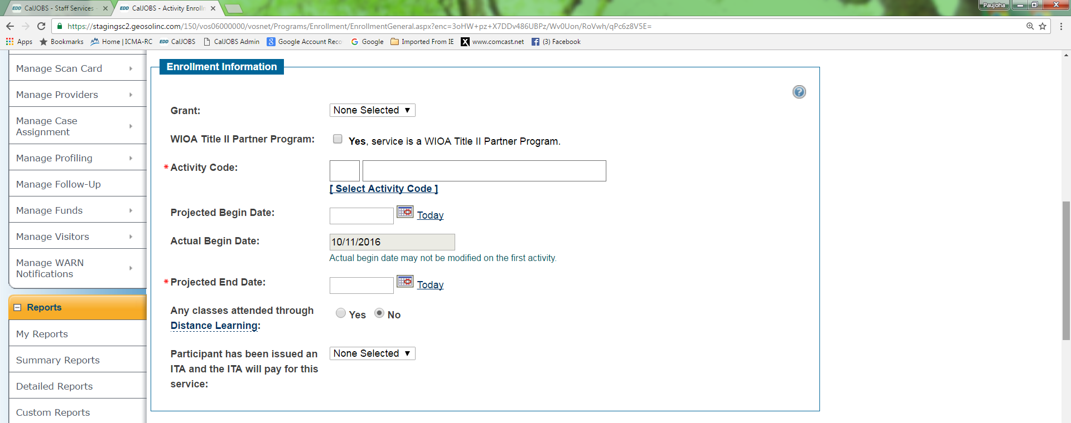

In the Staff Information section:
Position should reflect “Staff”

Assign Case Manager (if staff are logged in as themselves AND they will be the customer’s Case Manager, choose Assign Me). If support staff are creating the Participation for the Coach they can choose Assign Case Manager, then select the appropriate center, and locate the Coach’s name in the list of staff assigned to that center.

Select “Next” at the bottom of the screen
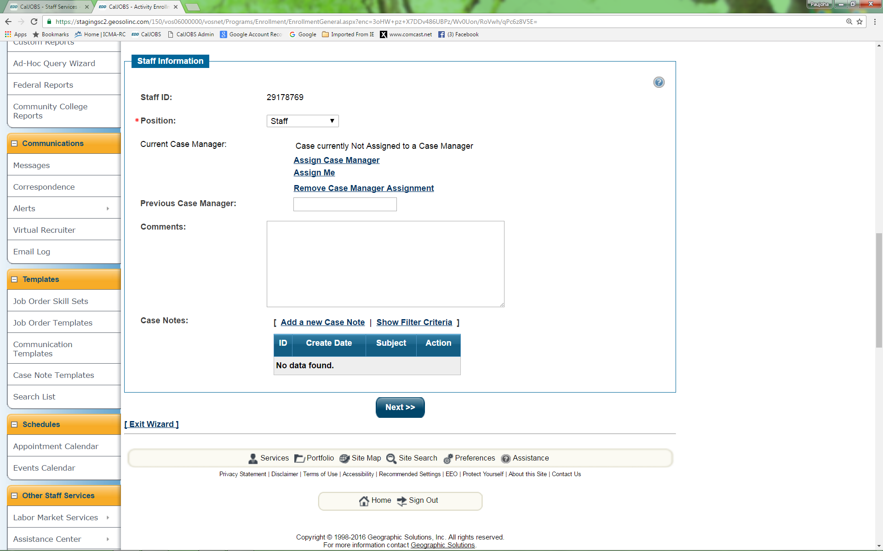

In the Enrollment Service Provider Information section:
SETA/SacWorks should be selected as the Provider
Select Basic Career Services (Adult/DW) in the Service, Course or Contract

Select “Next” at the bottom of the screen

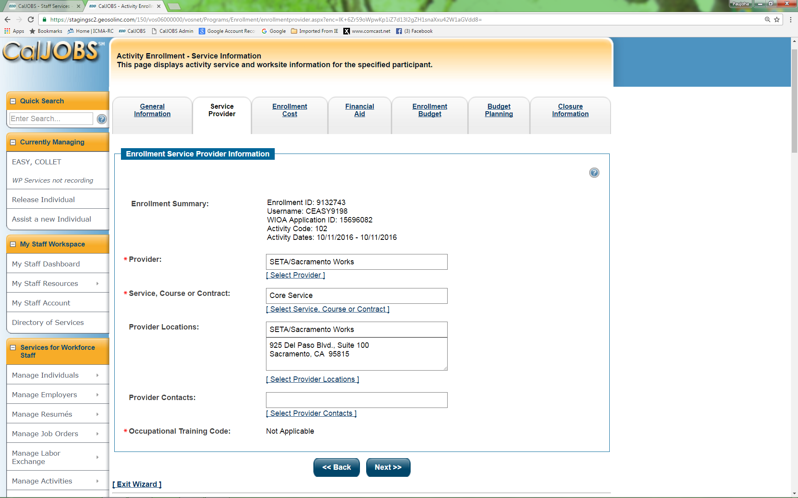

In the Closure Information section:
Select the same date as the Begin and End Dates for the Last Activity Date
Select Successful Completion for the Completion Code.

Select “Finish” at the bottom of the screen

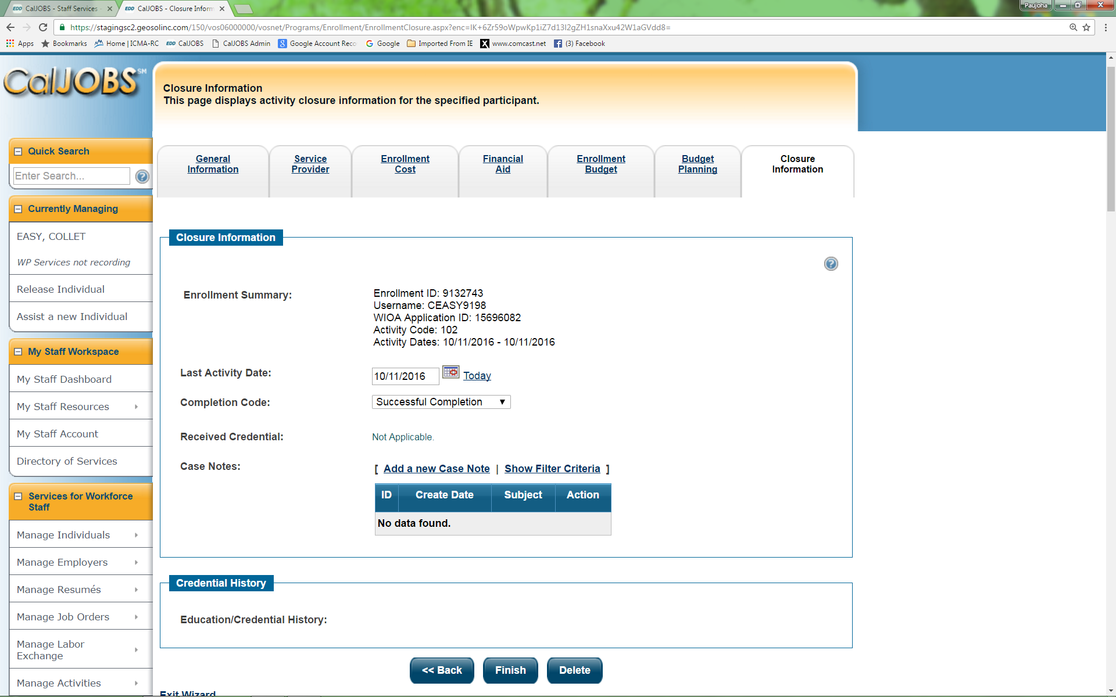

The Participation (Initial Assessment) Activity appears as shown below.

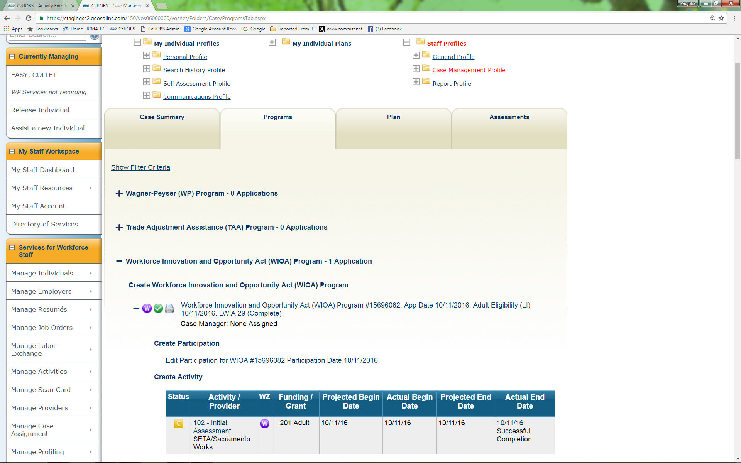
Staff can now select the Create Activity link to create additional Activities (e.g. 200 – Individual Counseling, 205 – Development of IEP, etc.)



