Staff Tuition Reimbursement Cheat Sheet
(For SETA employees and Delegate Agency employees that work with/in Head Start.)
Are you taking classes? Did you know you can get your tuition reimbursed through SETA? Here’s what you need to do!
- Sign up for classes.
- Classes must be related to your work (i.e., ECE classes for your permit, accounting classes to further your knowledge, or other classes relative to your position or completion of a degree).
- Fill out the Pre-Approval and Tuition Reimbursement Request Form.
- Have your Supervisor sign the form. If you are delegate staff your Director or their designee must sign the form.
- Send it to SETA Human Resources—BEFORE THE CLASS(ES) START!
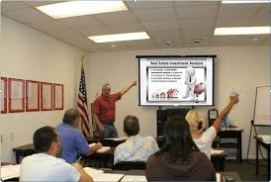
- Attend class(es).
- Get your grades.
- Turn in your paperwork, including:
- Copy of signed original Pre-Approval and Tuition Reimbursement Request Form.
- Final grade report (“C” or better).
- Original receipts for tuition and books.
- Class syllabus noting required books if seeking reimbursement for books.
- Statement of financial aid (signed and dated by school financial aid office).
- If you are a delegate staff your request must receive final approval by your Director or their designee before payment is authorized by SETA.
- Get your reimbursement.
- REMEMBER…

