

**Injury and Illness Prevention Program**

Revised 01/14/22

Table of Contents

INTRODUCTION 3

RESPONSIBILITY 3

COMPLIANCE 4

COMMUNICATION 4

Safety Suggestions and Recommendations 5

HAZARD ASSESSMENT 5

Injury Accident/Exposure Reporting 6

Investigation of Accidents/Exposures 7

HAZARD CORRECTION 7

TRAINING 8

CORONAVIRUS (COVID-19) 8

Infection Prevention Measures 8

Employee Training 10

Washing Facilities 11

Personal Protective Equipment (PPE) 11

RECORD KEEPING 11

MANUAL OF PROCEDURES FOR SAFETY AND ACCIDENT/ ILLNESS PREVENTION 12

General 12

Head Start Kitchen 12

Head Start Classroom/Playground 13

APPENDIX A: HAZARD ASSESSMENT CHECKLIST 15

APPENDIX B: EMPLOYEE INCIDENT REPORT 20

APPENDIX C: WITNESS INCIDENT REPORT 21

APPENDIX D: ACCIDENT, ILLNESS AND INJURY INVESTIGATION FORM 22

APPENDIX E: INDIVIDUAL EMPLOYEE TRAINING DOCUMENTATION 24

# INTRODUCTION

Every California employer must establish, implement and maintain a written Injury and Illness Prevention Program (IIPP) manual and a copy must be maintained at each worksite. The requirements for the IIPP are contained in **Title 8 of the California Code of Regulations, Section 3203 (T8 CCR 3203)** to protect employees from workplace hazards, including infectious diseases.

It is the intent of the Agency to comply with all laws. To do this, the Agency must constantly be aware of conditions in all work areas that can produce injuries. Inform your supervisor and/or a member of the Safety Committee immediately of any situation beyond your ability or authority to correct, or of any on-going hazard that doesn’t seem to get corrected.

This Illness and Injury Prevention Program hereby makes provision for:

1. The establishment of primary and secondary responsibilities for accident prevention.
2. The development of Agency-wide safety policies and procedures that align with federal and state regulations per program agreements.
   1. The identification and determination if an infectious disease as provided by the Centers for Disease Control and Prevention (CDC) is a hazard in the workplace (i.e., Coronavirus Disease 2019).
3. A Manual of Procedures of safety and accident prevention.
4. Job training in the safety factors inherent in each employee’s required duties.
5. The investigation of job incurred accidents and illnesses which do occur.
6. The inspection of Agency facilities for unsafe conditions.
7. The compilation and analysis of data regarding the occurrence of accidents.

# RESPONSIBILITY

1. The primary responsibility for the implementation and maintenance of the Injury and Illness Prevention Program rests with the Executive Director and Human Resources Chief. In order to ensure efficient operation of this program, these responsibilities can be delegated to other employees when deemed advisable. In general, the Executive Director and Human Resources Chief are responsible for the following:
2. Ensuring that all employees are trained in workplace safety in accordance with this program.
3. Inspecting, recognizing and evaluating workplace hazards consistent with the provisions of this program.
4. Ensuring that known or discovered workplace hazards are promptly abated.
5. Managers, Safety Committee members, and supervisors are responsible for implementing and maintaining the IIPP manual in their work sites and for answering employee questions about the program. A copy of this IIPP manual is available at each work site.

# COMPLIANCE

Management is responsible for ensuring that all safety, health, and workplace security policies and procedures are clearly communicated and understood by all employees. Supervisors are expected to enforce the rules fairly and uniformly. All employees are responsible for using safe work practices, for following all directives, policies and procedures, and for assisting in maintaining a safe and secure work environment. The following is SETA’s system of ensuring that all employees comply with the rules and maintain a safe and secure work environment:

1. Informing employees of the provisions of SETA’s IIPP.
2. Evaluating the safety performance of all employees.
3. Recognizing employees who perform safe and healthful work practices and promote security in the workplace.
4. Providing additional training to employees whose safety performance is deficient.
5. Disciplining employees for failure to comply with safe, healthful, and workplace security practices.

# COMMUNICATION

The Safety Committee along with all members of the management staff are responsible for communicating with all employees about workplace safety, health, and security issues in a form that is easily understandable. Our communication system encourages all employees, vendors, volunteers and/or guests to advise the Safety Committee or any member of the management staff about workplace safety, health, or security issues without fear of reprisal.

SETA’s communication system includes, but is not limited to, the following:

1. New employee orientation, including training on safety, health, and security policies and procedures, as well as the IIPP.
2. Follow-through by supervision to ensure effectiveness of the IIPP and ensure understanding by all employees.
3. Worksite-specific safety, health, and security training by the supervisor.
4. Regularly scheduled safety meetings at the site level with all employees that include workplace safety, health, and security discussions.
5. Posted and distributed safety, health and security information.
6. Procedures for protecting employees who report threats of retaliation for reporting workplace safety, health, or security concerns.
7. Addressing safety, health, and security concerns at Safety Committee meetings.
8. A system for employees to anonymously inform management about workplace hazards or security issues – by leaving a message on 916-563-5022.

The Agency elects to use a labor/management safety and health committee for meeting all the requirements of [T8CCR 3203 (7)(c)(1) – (7)](http://www.dir.ca.gov/title8/3203.html) to comply with the communication requirements of subsection (a)(3) of T8CCR 3203.

## 

## **Safety Suggestions and Recommendations**

1. Every employee of the Agency shall be encouraged to submit written safety suggestions or recommend measures for the elimination of unsafe work practices and/or unsafe physical conditions. All safety suggestions or recommendations shall be presented by the employee to his/her immediate supervisor. The suggestion or recommendation shall be processed through regular lines of authority.
2. Those suggestions and/or recommendations that cannot be finally approved or disapproved at the Unit level shall be referred to Human Resources.
3. If an employee feels self-conscious about reporting a workplace hazard, he or she is encouraged to provide an anonymous written report to Human Resources.
4. Under no circumstances will any form of reprisal be taken against any employee for making a report under this program.

# HAZARD ASSESSMENT

Inspections of the workplace will be conducted on an annual basis under the supervision of qualified personnel. The purpose of such inspections is to determine if any potential safety or health hazards exist in the workplace. Annual inspections will include inspection of all SETA facilities. If hazards are identified, appropriate action should be taken to alleviate the hazard or inform all employees of its existence and appropriate measures to be taken by employees to avoid the hazard. Annual inspections should include, but not be limited to, the following: fire extinguishers and escape routes; playground equipment and facilities; office maintenance and cleanliness; and parking facilities. Whenever possible, the Human Resources Department will accept reports from other departments that perform on-going monitoring, daily checklists, and/or self-assessment reviews, as long as the reviews cover the essential health and safety items listed above. **Appendix A: Hazard Assessment Checklist.**

In addition to the annual inspection, inspections shall occur:

1. When the Injury and Illness Prevention Program is first established.
2. Whenever new substances, processes, procedures or equipment are introduced into the workplace that represent a new occupational safety and health hazard.
3. When the Safety Committee or Human Resources is made aware of a new or previously unrecognized hazard; and
4. When an occupational injury or illness occurs.

## **Injury Accident/Exposure Reporting**

1. Any employee who is involved in an accident/exposure which causes injury, illness, or property damage (in the course of performing duties) is required to notify his/her supervisor or Human Resources immediately.
2. Any supervisor who receives notification from an employee is required to notify Human Resources immediately. An injury report shall be completed by the Human Resources Department or by the supervisor of any employee who sustains a work-incurred injury or illness. This report is to be sent to Human Resources as soon as possible.
3. Each employee is responsible for adhering to the following procedures:
   1. Report all job injuries immediately, regardless of seriousness, to the immediate supervisor.
   2. Complete an incident report and return to Human Resources within 24 hours. See **Appendix B: Employee Incident Report.**
   3. Secure first aid for minor injuries immediately.
4. Prompt reporting by injured employees is essential for the timely processing of workers’ compensation insurance claims. Human Resources will file a workers’ compensation claim within 24 hours of the injury/illness notification.
5. It shall be the duty of the employee operating any motor vehicle (in the course of performing duties) which becomes involved in an accident to immediately notify the Police Department so that the accident may be investigated by an officer at the time and place of the accident.
6. When an employee operating any motor vehicle (in the course of performing duties) is involved in an accident outside the city limits of Sacramento, the California Highway Patrol or other applicable law enforcement agency shall be called to make an accident report. In no case will an involved employee answer questions or discuss the accident with anyone except such persons representing the Agency and law enforcement officers investigating the accident.
7. Any employee who witnesses an injury/accident to a member of the public while on SETA premises shall notify his/her immediate supervisor and render all possible assistance

to the person(s) involved. See **Appendix C: Witness Incident Report**.

## **Investigation of Accidents/Exposures**

1. Human Resources shall investigate every accident/exposure causing personal injury/illness or property damage which is reported. Accident cause factors fall into three general categories: unsafe physical acts by people, unsafe physical conditions, or a combination of unsafe conditions or unsafe acts. The purpose of the investigation is to determine causes. It is not the purpose of the investigation to fix blame. See **Appendix D:** **Accident, Illness and Injury Investigation Form**.
2. The Department Deputy Director/Chief may require additional investigation of accidents which occur in his/her department. Human Resources may require or conduct additional investigation of any accident involving the Agency when additional information is deemed necessary.
3. All reports of accident/exposure investigations are confidential and are not to be released to any outside party without specific authorization of the Executive Director.

# HAZARD CORRECTION

Unsafe, unhealthy, or unsecure work conditions, practices or procedures at SETA’s work facilities shall be corrected in a timely manner based on the severity of when they are first observed or discovered, and according to the following procedures:

1. When an imminent hazard exists, which cannot be immediately abated without endangering employee(s) and/or property, Human Resources will remove all exposed employees from the area except those necessary to correct the existing condition. Employees necessary to correct the hazardous condition shall be provided with the necessary protection.
2. Controlling access to the workplace and freedom of movement within it, consistent with business necessity.
3. Ensuring the adequacy of workplace security systems, such as door locks, security windows, physical barriers and restraint systems.
4. Providing employee training in recognizing and handling threatening or hostile situations that may lead to violent acts by persons who are service recipients of the Agency.
5. Placing effective systems to warn others of a security danger or to summon assistance (i.e. panic button).
6. Ensuring adequate employee escape routes.
7. All such actions taken and dates they are completed shall be documented on the Hazard Assessment Checklist.

# TRAINING

The Agency will provide detailed training to new and existing employees regarding proper employee conduct that ensures, to the best extent possible, the safety of employees, participants, children and families. Training will include general safe work practices and on hazards specific to an employee’s job assignments and work tasks. This training will be reviewed and expanded as necessary to include any newly discovered areas of concern regarding safety and health in the workplace. Any questions regarding the current training programs should be directed to the appropriate Department Deputy Director or Chief.

Safety training will be conducted:

1. At all new employee orientations.
2. When an employee is given a new job assignment for which training was not previously provided.
3. Whenever new substances, processes, procedures or equipment are introduced to the workplace and represent a new hazard.
4. Whenever a new or previously recognized hazard is brought to the attention of, or discovered by, the Human Resources Department.
5. For supervisors, when necessary to familiarize them with the safety and health hazards to which employees under their immediate direction and control may be exposed.
6. For safety disciplinary procedures.
7. Periodically for refresher training.

Records of safety training may be documented on **Appendix E: Individual Employee Training Documentation**.

# CORONAVIRUS (COVID-19)

California employers are required to implement infection control measures for all workplace hazards, including COVID-19. SETA’s COVID-19 infection control measures include, but are not limited to, the following:

## **Infection Prevention Measures**

* 1. Actively encourage sick employees to stay home.
  2. Immediately send employees home or to medical care, as needed, if they have any COVID-19 symptoms as defined by the Centers for Disease Control (CDC).
  3. Ensure employees who are out ill with COVID-19 symptoms or test positive do not return to work until they meet the criteria to discontinue home isolation, in consultation with healthcare providers, per CDC guidelines.
  4. Provide employees with California Paid Sick Leave or expanded family and medical leave for specified reasons related to COVID-19 if required to by the Families First Coronavirus Response Act.
  5. Ensure employees that return to work following an illness promptly report any recurrence of symptoms.
  6. Encourage employees to telework from home when possible.
  7. Practice physical distancing by cancelling in-person meetings, using video or telephonic meetings, and maintaining a distance of at least 6 feet between persons at the workplace when possible.
  8. Provide employees with face coverings or encourage employees to use their own face coverings for use whenever employees may be in workplaces with other persons. Face coverings are not personal protective equipment (PPE), but combined with physical distancing of at least six feet, they may help prevent infected persons without symptoms from unknowingly spreading COVID-19.
  9. Avoid shared workspaces (desks, offices, and cubicles) and work items (phones, computers, other work tools, and equipment) when possible.
     1. If they must be shared, clean and disinfect shared workspaces and work items before and after use.
  10. Establish procedures to routinely clean and disinfect commonly touched objects and surfaces such as copy machines, faucets, and doorknobs. Surfaces should be cleaned with soap and water prior to disinfection. These procedures should include:
      1. Using disinfectants that are EPA-approved for use against the virus that causes COVID-19.
      2. Providing EPA-registered disposable wipes for employees to wipe down commonly used surfaces before use.
      3. Following the manufacturer’s instructions for all cleaning and disinfection products (e.g., safety requirements, PPE, concentration, contact time).
      4. Ensuring there are adequate supplies to support cleaning and disinfection practices.
  11. If an employee is confirmed to have the COVID-19 infection:
      1. Inform employees of their possible exposure to COVID-19 in the workplace but maintain confidentiality as required by the Americans with Disabilities Act (ADA) and California Department of Fair Employment and Housing (DFEH).
      2. Follow CDC’s guidelines on cleaning and disinfecting if it has been seven days or less since the individual who tested positive has been at the site. Temporarily close the general area where the infected employee worked until cleaning is completed.

1. Conduct deep cleaning of the entire general area where the infected employee worked and may have been, including breakrooms and restrooms, with a cleaning agent approved for use by the EPA against coronavirus. It should ideally be performed by a professional cleaning service.
   1. Any person cleaning the area should be equipped with gloves for COVID-19 disinfection in addition to PPE required for cleaning products. See below for further information on PPE.
   2. Advise employees to avoid non-essential travel if possible and check CDC’s Traveler’s Health Notices prior to travel.

## 

## **Employee Training**

Employees will be trained on the following regarding Coronavirus (COVID-19):

1. General description of COVID-19 symptoms, when to seek medical attention, how to prevent its spread, and the employer’s procedures for preventing its spread at the workplace.
2. How an infected person can spread COVID-19 to others even if they are not sick.
3. How to prevent the spread of COVID-19 by using face coverings, including:
   1. CDC guidelines that everyone should use face coverings when around other persons.
   2. How cloth/disposable face coverings can help protect persons around the user when combined with physical distancing and frequent hand washing.
   3. Information that face coverings are not protective equipment and do not protect the person wearing a cloth/disposable face cover from COVID-19.
   4. Instructions on washing and sanitizing hands before and after using face coverings, which should be washed after each shift if they are cloth.
4. Cough and sneeze etiquette.
5. Washing hands with soap and water for at least 20 seconds, after interacting with other persons and after contacting shared surfaces or objects.
6. Avoiding touching eyes, nose, and mouth with unwashed hands.
7. Avoiding sharing personal items with other employees (i.e., dishes, cups, utensils, towels).
8. Providing tissues, no-touch disposal trash cans and hand sanitizer for use by employees.
9. Safely using cleaners and disinfectants, which includes:
   1. The hazards of the cleaners and disinfectants used at the worksite.
   2. Wearing PPE (such as gloves).
   3. Ensuring cleaners and disinfectants are used in a manner that does not endanger employees.

## 

## **Washing Facilities**

The Agency provides washing facilities that have an adequate supply of suitable cleansing agents, water, and single-use towels or blowers.

## 

## **Personal Protective Equipment (PPE)**

The Agency conducts hazard assessments to determine if any PPE is needed to protectemployees from hazards that are present or are likely to be present in the workplace, including health hazards. The Agency selects and provides employees with properly fitting and sanitary PPE that will effectively protect them against these hazards, if applicable. The Agency also ensures the appropriate PPE is provided to and used by employees who use cleaners and disinfectants.

# RECORD KEEPING

Human Resources shall maintain all written records consistent with this program for a period of five (5) years from the date of preparation. These records should include the following:

* + 1. Records of scheduled and periodic inspections including the person(s) conducting the inspection, the workplace hazards (i.e., unsafe conditions and work practices that have been identified), and the action(s) taken to correct the identified unsafe conditions and work practices. See **Appendix** **A: Hazard Assessment Checklist**.
    2. Applicable OSHA paperwork.
    3. Documentation of safety, health, and security training for each employee, including the employee’s name, training dates, topics of training, and training providers. See **Appendix E: Individual Employee Training Documentation**.

# MANUAL OF PROCEDURES FOR SAFETY AND ACCIDENT/ ILLNESS PREVENTION

The following job safety practices are used to train employees of the Sacramento Employment and Training Agency. These practices will be modified as necessary if additional hazards are recognized by staff. All employees will be trained on the work area safety practices (upon hire) as well as emergency evacuation procedures. A copy of the document will be provided to every employee during the safety training.

# 

## **General**

* + 1. Report all unsafe conditions, accidents, injuries, and illnesses to your supervisor immediately.
    2. In the event of a fire, remain calm and leave the building at the nearest exit. Follow evacuation procedures as set forth in training.
    3. Access to fire extinguishers, aisles, and hallways shall be kept clear at all times.
    4. Employees shall not store excess combustibles (paper) in nearby work areas.
    5. Clean all spills and remove obstructive objects from floors at all times.
    6. Use the handrail when walking up/down the staircase.
    7. Do not leave file cabinet drawers open, and do not open more than one file cabinet drawer at any one time.
    8. Report inadequate lighting to your supervisor for correction if necessary.
    9. Abide by all safety practices above, and notify your supervisor of hazards which you may come across.

# 

## **Head Start Kitchen**

Employees assigned to the Head Start Food Services Department are mandated to follow federal and state food handling regulations. Violations of such regulations could pose a threat to the safety of the food and to the food handler. Below are general safety precautions; however, always refer to the CFS Head Start Manuals/Policies for guidance:

1. Employees in the Head Start kitchen are not to wear any jewelry.
2. Employees must wear sturdy, closed heel and toe, low-heeled shoes with a non-slip sole and preferably with a steel toe. Shoes must be clean and in good condition.
3. Hair restraints are required by local, state, and federal health codes. Nets, hats and caps may be used. Employees with beards should wear beard restraints. Food handlers shall wear approved hair restraints at all times.
4. Only contacts and glasses medically prescribed by a doctor are allowed in the food preparation areas. Ornamental eyewear is considered jewelry and could pose a safety hazard.
5. Excessive make-up is not allowed in the food preparation areas. Excessive make-up can get on clothing and into the food during the preparation.
6. Handwashing and gloving procedures must be adhered to at all times.
7. Kitchen equipment should only be operated in the appropriate manner.
8. Keep floors clean and wipe up spills immediately.

## 

## **Head Start Classroom/Playground**

Follow and/or reference the CFS Head Start Manuals/Policies for guidance on Classroom/Playground safety. All safety regulations are based on Federal Head Start Regulations, CA Title 22 Health and Safety Codes as well as Education Codes Title 5.

* 1. Incidental Medication Services Plan of Operations will be followed in the handling and storage of any medications as well as incidental medical services provided at and/or stored in a Head Start licensed facility.

1. For Pesticide Control Management, please reference the CFS Head Start Program safety protocols for proper guidance on training and procedures for handling of such pesticides.

1. Temperature/ventilation systems are to be adequately maintained, in working and good condition as determined by monitoring protocols for CFS Head Start.
2. Keep lids on all trash cans closed.
3. Outdoor equipment, structures and environments should be free of debris, sharp objects and other potential hazards as outlined in the CFS Head Start Program Safe Environments Policy and Procedures.
4. Slides must have horizontal steps and good tread.
5. Metal equipment should be shaded from the sun.

**APPENDICES**

# APPENDIX A: HAZARD ASSESSMENT CHECKLIST

Instructions: In each section, mark Yes (item is completed), No (Item is incomplete), or N/A (Not applicable)

All items that are incomplete and marked “No” require action for correction either immediately or within a reasonable timeframe.

|  |  |  |
| --- | --- | --- |
| **Site:** | **Person Completing Assessment:** | **Date:** |

|  |  |  |  |  |  |  |
| --- | --- | --- | --- | --- | --- | --- |
| **Center Postings** | **Yes** | **No** | **N/A** | **Corrections Needed** | **Person Assigned to Correct** | **Date Corrected** |
| The Emergency Disaster Plan (LIC 610) is posted prominently with up-to-date staff assignments. |  |  |  |  |  |  |
| Earthquake Preparedness Checklist (LIC 9148) is completed/implemented and attached to the Emergency Disaster Plan (LIC 610). |  |  |  |  |  |  |
| Emergency evacuation procedures are posted. |  |  |  |  |  |  |
| **Facility Inspection** | **Yes** | **No** | **N/A** | **Corrections Needed** | **Person Assigned to Correct** | **Date Corrected** |
| Cleaning agents, flammable or poisonous supplies are labeled and stored properly. |  |  |  |  |  |  |
| Center temperature is maintained between 68 degrees and 85 degrees (in cases of extreme heat, center temperature cannot exceed 20 degrees less than the outside temperature). |  |  |  |  |  |  |
| There is evidence of earthquake and fire drills performed per established schedule. |  |  |  |  |  |  |
| Material Safety Data Sheet (MSDS) book is easily accessible and all staff are aware of the MSDS. |  |  |  |  |  |  |
| **Kitchen/Food Preparation Area Inspection** | **Yes** | **No** | **N/A** | **Corrections Needed** | **Person Assigned to Correct** | **Date Corrected** |
| Hot water registers no less than 105 degrees and no more than 120 degrees, if applicable. |  |  |  |  |  |  |
| Garbage containers are covered and contents are disposed of properly. |  |  |  |  |  |  |
| The refrigerator and microwave are clean. |  |  |  |  |  |  |
| Food preparation area including counters, tabletops and floors are clean/swept. |  |  |  |  |  |  |
| **Restroom Inspection/Observation** | **Yes** | **No** | **N/A** | **Corrections Needed** | **Person Assigned to Correct** | **Date Corrected** |
| The restrooms are clean, free of odor and well-maintained. |  |  |  |  |  |  |
| **Center Inspection/Observation** | **Yes** | **No** | **N/A** | **Corrections Needed** | **Person Assigned to Correct** | **Date Corrected** |
| Accurate emergency numbers are posted near the telephone in the Center. |  |  |  |  |  |  |
| Procedures for poisoning, CPR, choking and dental emergencies are posted in the Center. |  |  |  |  |  |  |
| First aid manual is located in the Center and is accessible to staff. |  |  |  |  |  |  |
| An onsite evacuation map is prominently displayed by the door in the Center. |  |  |  |  |  |  |
| Exits are clearly marked with signage. |  |  |  |  |  |  |
| Exits in the Center are unobstructed and have a 3-foot clearance. |  |  |  |  |  |  |
| Fire extinguishers are mounted, accessible and clearly marked. |  |  |  |  |  |  |
| Fire extinguishers are serviced annually from date of last inspection and evidenced by service tag. |  |  |  |  |  |  |
| There are working smoke detectors, fire alarms or sprinkler system in the Center. |  |  |  |  |  |  |
| Electrical cords and surge protectors do not pose trip hazards. |  |  |  |  |  |  |
| Electrical cords do not obstruct foot traffic or doorways. |  |  |  |  |  |  |
| Decorative materials or postings are not blocking exits or emergency equipment. |  |  |  |  |  |  |
| The Center is clean, free of odor and well-maintained. |  |  |  |  |  |  |
| Are aisles and passageways kept clear? |  |  |  |  |  |  |
| Are holes in the floor, sidewalk or other walking surface repaired properly, covered or otherwise made safe? |  |  |  |  |  |  |
| Are steps on stairs and stairways designed or provided with a surface that renders them slip resistant? |  |  |  |  |  |  |

|  |  |  |  |  |  |  |
| --- | --- | --- | --- | --- | --- | --- |
| No personal electrical devices which pose a risk (e.g. personal heater, mini-fridge, etc.). |  |  |  |  |  |  |
| **Disaster Preparedness** | **Yes** | **No** | **N/A** | **Corrections Needed** | **Person Assigned to Correct** | **Date Corrected** |
| Staff are trained to react in emergencies (e.g., natural disasters, community violence, intruders, aggressive or belligerent clients). |  |  |  |  |  |  |
| Staff know the primary off-site evacuation location and procedure. |  |  |  |  |  |  |
| **Ergonomics** | **Yes** | **No** | **N/A** | **Corrections Needed** | **Person Assigned to Correct** | **Date Corrected** |
| Can the work be performed without eyestrain or glare to the employees? |  |  |  |  |  |  |
| Does the task require prolonged raising of the arms? |  |  |  |  |  |  |
| Do the neck and shoulders have to be stooped to view the task? |  |  |  |  |  |  |
| Are there pressure points on any parts of the body (wrists, forearms, back of thighs)? |  |  |  |  |  |  |
| Can the work be done using the larger muscles of the body? |  |  |  |  |  |  |
| **Staff Behavior** | **Yes** | **No** | **N/A** | **Corrections Needed** | **Person Assigned to Correct** | **Date Corrected** |
| Have staff been trained in proper lifting techniques? |  |  |  |  |  |  |
| Do staff demonstrate awareness of surroundings while walking through the work area (not looking at cellphone or papers while walking)? |  |  |  |  |  |  |
| Do staff only use approved step ladders or steps and not chairs to reach high objects? |  |  |  |  |  |  |
| Are excessive personal items or boxes stored in work area which may impede the ability to get work done? |  |  |  |  |  |  |

# APPENDIX B: EMPLOYEE INCIDENT REPORT

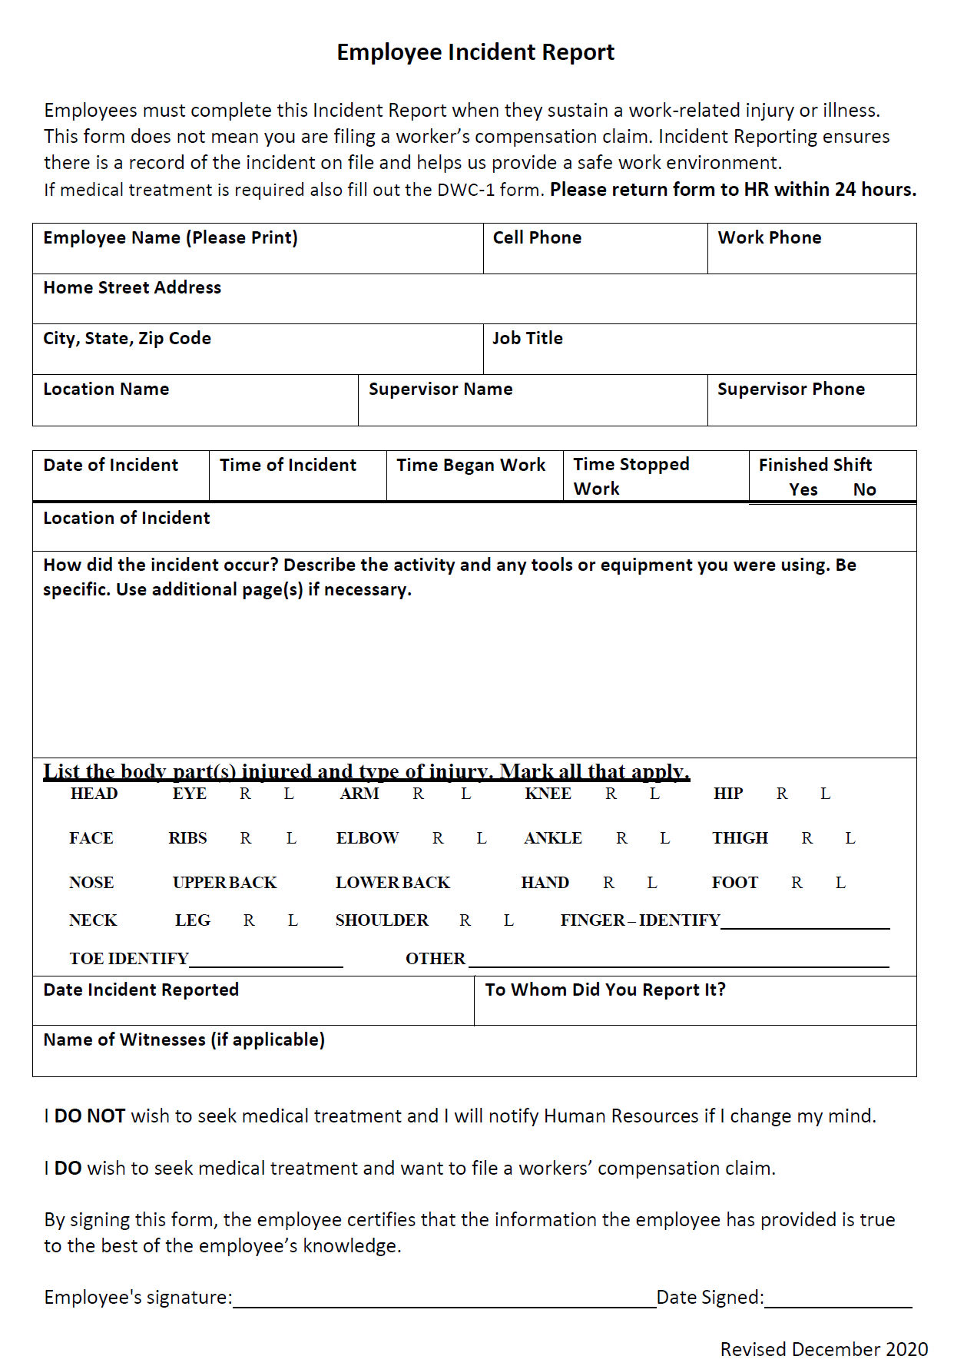

# APPENDIX C: WITNESS INCIDENT REPORT

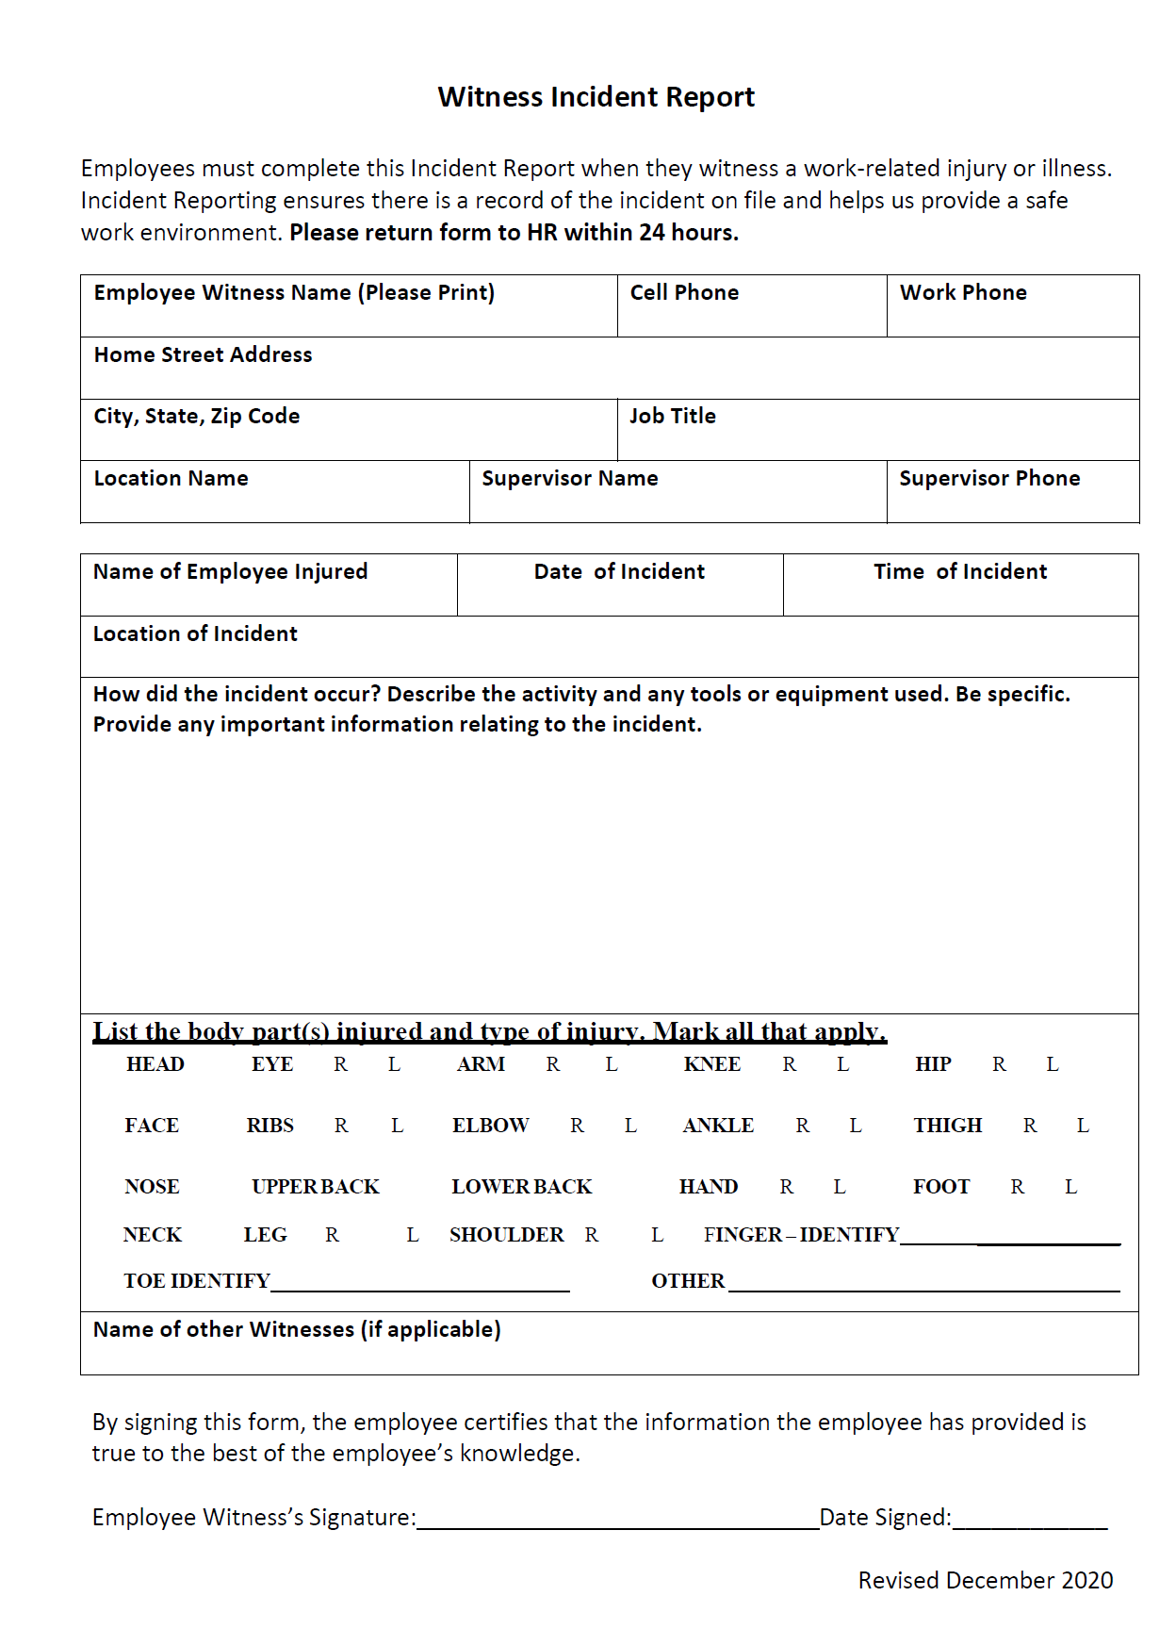

# APPENDIX D: ACCIDENT, ILLNESS AND INJURY INVESTIGATION FORM





# APPENDIX E: INDIVIDUAL EMPLOYEE TRAINING DOCUMENTATION



**INDIVIDUAL EMPLOYEE TRAINING DOCUMENTATION**

**Illness and Injury Prevention Program (IIPP)**

Name of Trainer: _____________________________________________________

Name of Employee: __________________________________________________

Date of Training: ______________________________________________________

____________________________________, hereby certify that I received IIPP training as described below:

* The potential occupational hazards in the general work area and associated with my job assignment.
* The Manual of Procedures for Safety and Accident Prevention which indicates the safe work conditions, safe work practices and personal protective equipment (if any) required for my work.
* The hazards of any chemicals to which I may be exposed and my right to information contained on material safety data sheets for those chemicals.
* My right to ask any questions, or provide any information to the employer on safety either directly or anonymously without any fear of reprisal.
* Disciplinary procedures the employer will use to enforce compliance with the Injury and Illness Prevention Program.

I understand this IIPP training and understand I am obligated to adhere to it.

__________________________________ _________________________

Employees Signature Date